Full Name | Sachin Rangnath Gawade
Batch | Dec 2020
Project Title | E-commerce Website for Sporty Shoes
Project Submission Date | 29-April – 2022
Git Hub Link | https://github.com/saching3234/simply_learn_sport_shoes_project

Source Code :-
Com.to.resources:- (Package)
1. AdminLoginResource.java

package com.to.resources;

import java.util.Date;
import java.util.HashMap;
import java.util.Map;
import org.springframework.beans.factory.annotation.Autowired;
import org.springframework.http.HttpStatus;
import org.springframework.http.ResponseEntity;
import org.springframework.web.bind.annotation.PostMapping;
import org.springframework.web.bind.annotation.RequestBody;
import org.springframework.web.bind.annotation.RequestMapping;
import org.springframework.web.bind.annotation.RestController;
import com.to.Constants;
import com.to.entities.AdminLogin;
import com.to.entities.User;
import com.to.services.AdminLoginService;
import io.jsonwebtoken.Jwts;
import io.jsonwebtoken.SignatureAlgorithm;

@RestController
@RequestMapping("/api/admin")
public class AdminLoginResource {

@Autowired
AdminLoginService adminLoginService;

@PostMapping("/login")
public ResponseEntity<Map<String, String>> loginAdmin(@RequestBody Map<String, Object> adminMap) {
String adminId = (String) adminMap.get("adminId");
String password = (String) adminMap.get("password");
// checking the admin id and password is correct or not
AdminLogin adminLogin = adminLoginService.adminLogin(adminId, password);
return new ResponseEntity<>(generateJWTToken(adminLogin), HttpStatus.OK);
}

@PostMapping("/changeAdminPass")
public Map<String, String> changeAdminPass(@RequestBody Map<String, Object> adminMap) {
String adminId = (String) adminMap.get("adminId");
String password = (String) adminMap.get("password");
String newPass = (String) adminMap.get("newPass");

// checking the admin id and password is correct or not
adminLoginService.adminPasswordChange(adminId, password, newPass);

Map<String, String> map = new HashMap<>();
map.put("Message", "Password Changed Successfully Login with new Password " + adminId);
return map;

}

// methodn for generating the tocken

private Map<String, String> generateJWTToken(AdminLogin adminLogin) {
// getting the current time in milisecods
long timestamp = System.currentTimeMillis();
String token = Jwts.builder().signWith(SignatureAlgorithm.HS256, Constants.API_SECRET_KEY_STRING)
.setIssuedAt(new Date(timestamp)).setExpiration(new Date(timestamp + Constants.TOKEN_VALIDITY))
.claim("adminId", adminLogin.getAdminId()).compact();

Map<String, String> map = new HashMap<>();
map.put("Succes", "Login Successfull Admin Use the given token");
map.put("token", token);
return map;

}

}

2. AdminCategoryResource.java

package com.to.resources;

import java.util.HashMap;
import java.util.List;
import java.util.Map;

import javax.servlet.http.HttpServletRequest;

import org.springframework.beans.factory.annotation.Autowired;
import org.springframework.http.HttpStatus;
import org.springframework.http.ResponseEntity;
import org.springframework.stereotype.Repository;
import org.springframework.web.bind.annotation.DeleteMapping;
import org.springframework.web.bind.annotation.GetMapping;
import org.springframework.web.bind.annotation.PatchMapping;
import org.springframework.web.bind.annotation.PathVariable;
import org.springframework.web.bind.annotation.PostMapping;
import org.springframework.web.bind.annotation.RequestBody;
import org.springframework.web.bind.annotation.RequestMapping;
import org.springframework.web.bind.annotation.RestController;

import com.to.entities.Category;
import com.to.entities.Product;
import com.to.services.CategoryService;
import com.to.services.ProductServices;

@RestController
@RequestMapping("/api/admin/category")
public class AdminCategoryResource {

@Autowired
CategoryService categoryService;

// controller for getting the all category details
@GetMapping("")
public ResponseEntity<List<Category>> getAllCategories(HttpServletRequest request) {
// getting the admin id
String adminId = (String) request.getAttribute("adminId");

List<Category> categories = categoryService.getAllCategories();
System.out.println(categories);
return new ResponseEntity<>(categories, HttpStatus.OK);
}

// controller for getting the specific category details
@GetMapping("/{catId}")
public ResponseEntity<Category> getCategoryById(HttpServletRequest request, @PathVariable("catId") Integer catId) {

// getting the admin Id
String adminId = (String) request.getAttribute("adminId");

// searching the category
Category category = categoryService.getCategoryById(catId);
System.out.println("get category by id called" + category + " " + catId);
return new ResponseEntity<>(category, HttpStatus.OK);
}

// controller for deleting the specific category details

@DeleteMapping("/delete/{catId}")
public ResponseEntity<Map<String, String>> deleteCategoryById(HttpServletRequest request,
@PathVariable("catId") Integer catId) {

// getting the admin Id
String adminId = (String) request.getAttribute("adminId");

// deleting the category
categoryService.deleteCategory(catId);
Map<String, String> map = new HashMap<>();
map.put("Success", "Category Id : " + catId + " Deleted Successfully");
return new ResponseEntity<>(map, HttpStatus.OK);
}

// controller for adding the new category details
@PostMapping("")
public ResponseEntity<Map<String, String>> addCategory(HttpServletRequest request,
@RequestBody Map<String, Object> catMap) {

// getting the admin id from tocken provided
String adminId = (String) request.getAttribute("adminId");

System.out.println("Control is here");
// adding category details into the bean
Category category = new Category();
category.setCatName((String) catMap.get("cname"));

// calling the service method to save the data
categoryService.createCategory(category.getCatName());

System.out.println("Control is here aftefr product");

Map<String, String> map = new HashMap<>();
map.put("msg", "Category Details added");
return new ResponseEntity<>(map, HttpStatus.OK);

}

// controller for updating existing category details
@PatchMapping("")
public ResponseEntity<Map<String, String>> updateCategory(HttpServletRequest request,
@RequestBody Map<String, Object> catMap) {

// getting the admin id from tocken provided
String adminId = (String) request.getAttribute("adminId");

System.out.println("Control is here");
// adding category details into the bean
Category category = new Category();
category.setCatId(Integer.parseInt((String) catMap.get("cid")));
category.setCatName((String) catMap.get("cname"));

// calling the service method to save the data
categoryService.updateCategory(category.getCatId(), category.getCatName());

Map<String, String> map = new HashMap<>();
map.put("msg", "Category Details updates Successfully");
return new ResponseEntity<>(map, HttpStatus.OK);

}

}

3. AdminProductResource.java

package com.to.resources;
import java.util.HashMap;
import java.util.List;
import java.util.Map;
import javax.servlet.http.HttpServletRequest;
import org.springframework.beans.factory.annotation.Autowired;
import org.springframework.http.HttpStatus;
import org.springframework.http.ResponseEntity;
import org.springframework.web.bind.annotation.GetMapping;
import org.springframework.web.bind.annotation.PathVariable;
import org.springframework.web.bind.annotation.PostMapping;
import org.springframework.web.bind.annotation.RequestBody;
import org.springframework.web.bind.annotation.RequestMapping;
import org.springframework.web.bind.annotation.RestController;
import com.to.entities.Product;
import com.to.entities.UserPurchase;
import com.to.services.ProductServices;

@RestController
@RequestMapping("/api/admin/product")
public class AdminProductResource {
@Autowired
ProductServices productServices;

// controller for getting the all product details
@GetMapping("")
public ResponseEntity<List<Product>> getAllProducts(HttpServletRequest request) {
String adminId = (String) request.getAttribute("adminId");
List<Product> products = productServices.getAllProductDetails();
System.out.println(products);
return new ResponseEntity<>(products, HttpStatus.OK);
}

// controller for getting the specific product details
@GetMapping("/{pId}")
public ResponseEntity<Product> getProductById(HttpServletRequest request, @PathVariable("pId") Integer pId) {
// getting the admin Id
String adminId = (String) request.getAttribute("adminId");
// searching the product
Product products = productServices.getProductById(pId);
System.out.println("get product by id called" + products + " " + pId);
return new ResponseEntity<>(products, HttpStatus.OK);
}

// controller for deleting the specific product details
@GetMapping("/delete/{pId}")
public ResponseEntity<Map<String, String>> deleteProductById(HttpServletRequest request,
@PathVariable("pId") Integer pId) {
// getting the admin Id
String adminId = (String) request.getAttribute("adminId");
// deleting the product
productServices.deleteProduct(pId);
Map<String, String> map = new HashMap<>();
map.put("Success", "Product Id : " + pId + " Deleted Successfully");
return new ResponseEntity<>(map, HttpStatus.OK);
}

// controller for adding the new product details
@PostMapping("")
public ResponseEntity<Map<String, String>> addProduct(HttpServletRequest request,
@RequestBody Map<String, Object> productMap) {
// getting the admin add from tocken provide
String adminId = (String) request.getAttribute("adminId");
System.out.println("Control is here");
// adding product details into the bean
Product prodcut = new Product();
prodcut.setPname((String) productMap.get("pname"));
prodcut.setPdescription((String) productMap.get("pdescription"));
prodcut.setPrice(Integer.parseInt(productMap.get("price").toString()));
prodcut.setGender((String) productMap.get("gender"));
prodcut.setCid(Integer.parseInt(productMap.get("cid").toString()));
// calling the service method to save the data
productServices.createNewProduct(prodcut);
System.out.println("Control is here aftefr product");
Map<String, String> map = new HashMap<>();
map.put("msg", "Product Details added");
return new ResponseEntity<>(map, HttpStatus.OK);

}

}

4. AdminReportsResource:-
package com.to.resources;
import java.util.List;
import javax.servlet.http.HttpServletRequest;
import org.springframework.beans.factory.annotation.Autowired;
import org.springframework.http.HttpStatus;
import org.springframework.http.ResponseEntity;
import org.springframework.web.bind.annotation.GetMapping;
import org.springframework.web.bind.annotation.RequestMapping;
import org.springframework.web.bind.annotation.RestController;

import com.to.entities.Product;
import com.to.entities.User;
import com.to.services.AdminReportService;
import com.to.services.ProductServices;

@RestController
@RequestMapping("/api/admin/report")
public class AdminReportsResource {
@Autowired
AdminReportService adminReportService;

// controller for getting the all product details
@GetMapping("/loggedUsers")
public ResponseEntity<List<User>> getAllUsers(HttpServletRequest request) {
//getting the admin od from tocken
String adminId = (String) request.getAttribute("adminId");

List<User> users = adminReportService.getAllLoggedUsersDetails();
System.out.println(users);
return new ResponseEntity<>(users, HttpStatus.OK);
}

}

5. UserResource.java:-

package com.to.resources;
import java.util.Date;
import java.util.HashMap;
import java.util.Map;
import org.springframework.beans.factory.annotation.Autowired;
import org.springframework.http.HttpStatus;
import org.springframework.http.ResponseEntity;
import org.springframework.web.bind.annotation.PostMapping;
import org.springframework.web.bind.annotation.RequestBody;
import org.springframework.web.bind.annotation.RequestMapping;
import org.springframework.web.bind.annotation.RestController;
import com.to.Constants;
import com.to.entities.User;
import com.to.services.UserService;
import io.jsonwebtoken.Jwts;
import io.jsonwebtoken.SignatureAlgorithm;
@RestController
@RequestMapping("/api/users")
public class UserResource {
@Autowired
UserService userService;

@PostMapping("/register")
public ResponseEntity<Map<String, String>> registerUser(@RequestBody Map<String, Object> userMap) {
String firstName = (String) userMap.get("fname");
String lastName = (String) userMap.get("lname");
String email = (String) userMap.get("email");
String password = (String) userMap.get("password");
User user = userService.registerUser(firstName, lastName, email, password);

return new ResponseEntity<>(generateJWTToken(user), HttpStatus.OK);
}

@PostMapping("/loginuser")
public ResponseEntity<Map<String, String>> loginUser(@RequestBody Map<String, Object> userMap) {
String emailString = (String) userMap.get("email");
String passwordString = (String) userMap.get("password");
// checking the user id and password is correct or not
User user = userService.validateUser(emailString, passwordString);

return new ResponseEntity<>(generateJWTToken(user), HttpStatus.OK);
}

// methodn for generating the tocken

private Map<String, String> generateJWTToken(User user) {
// getting the current time in milisecods
long timestamp = System.currentTimeMillis();
String token = Jwts.builder().signWith(SignatureAlgorithm.HS256, Constants.API_SECRET_KEY_STRING)
.setIssuedAt(new Date(timestamp)).setExpiration(new Date(timestamp + Constants.TOKEN_VALIDITY))
.claim("userId", user.getUserId()).claim("email", user.getEmail()).claim("firstName", user.getFname())
.claim("lastName", user.getLname()).compact();

Map<String, String> map = new HashMap<>();
map.put("token", token);
return map;

}

}
}

6. UserPurchaseResource.java

package com.to.resources;
import java.util.HashMap;
import java.util.List;
import java.util.Map;
import javax.servlet.http.HttpServletRequest;
import org.springframework.beans.factory.annotation.Autowired;
import org.springframework.http.HttpStatus;
import org.springframework.http.ResponseEntity;
import org.springframework.web.bind.annotation.GetMapping;
import org.springframework.web.bind.annotation.PathVariable;
import org.springframework.web.bind.annotation.PostMapping;
import org.springframework.web.bind.annotation.RequestBody;
import org.springframework.web.bind.annotation.RequestMapping;
import org.springframework.web.bind.annotation.RestController;

import com.to.entities.Product;
import com.to.entities.UserPurchase;
import com.to.services.UserPurchaseService;

@RestController
@RequestMapping("/api/userPurchase")
public class UserPurchaseResource {

@Autowired
UserPurchaseService userPurchaseService;

@GetMapping("")
public ResponseEntity<List<UserPurchase>> getAllPurchase(HttpServletRequest request) {
int userId = (Integer) request.getAttribute("userId");
List<UserPurchase> userPurchases = userPurchaseService.fetchAllPurchases(userId);
System.out.println(userPurchases);
return new ResponseEntity<>(userPurchases, HttpStatus.OK);
}

@GetMapping("/products/{catId}")
public ResponseEntity<List<Product>> getAllProductCategorywise(HttpServletRequest request,
@PathVariable("catId") Integer catId) {
int userId = (Integer) request.getAttribute("userId");
List<Product> products = userPurchaseService.getAllProductByCategory(catId);
System.out.println(products);
return new ResponseEntity<>(products, HttpStatus.OK);
}

// controller for adding the purchase details
@PostMapping("")
public ResponseEntity<Map<String, String>> addUserPurchase(HttpServletRequest request,
@RequestBody Map<String, Object> userMap) {
Integer userId = (Integer) request.getAttribute("userId");

System.out.println("Control is here");

UserPurchase userPurchase = new UserPurchase();
userPurchase.setProduct_id(Integer.parseInt(userMap.get("product_id").toString()));
userPurchase.setPdate((String) userMap.get("pdate"));
userPurchase.setCat_id(Integer.parseInt(userMap.get("cat_id").toString()));
userPurchase.setQuantity(Integer.parseInt(userMap.get("quantity").toString()));
userPurchase.setPrice(Integer.parseInt(userMap.get("price").toString()));
userPurchase.setTotal_price(Integer.parseInt(userMap.get("total_price").toString()));
userPurchase.setUser_id(userId);

System.out.println("Control is here before add purchase");
userPurchaseService.addPurchase(userPurchase);
System.out.println("Control is here aftefr add purchase");
Map<String, String> map = new HashMap<>();
map.put("msg", "Purchase Details added" + userPurchase);

return new ResponseEntity<>(map, HttpStatus.OK);

}

// method for getting the purchase details by id
@GetMapping("/{purId}")
public ResponseEntity<UserPurchase> getUserPurchaseById(HttpServletRequest request,
@PathVariable("purId") Integer purId) {
// getting the logged user id
int userId = (Integer) request.getAttribute("userId");
// calling the fetch method
UserPurchase userPurchase = userPurchaseService.fetchUserPurchaseById(userId, purId);
return new ResponseEntity<>(userPurchase, HttpStatus.OK);
}

}

-------------------------------------------------------------------------------------------------------------------------------------------

Com.to.filters:- (Package)
- AdminAuthFilter.java

package com.to.filters;
import java.io.IOException;
import javax.servlet.FilterChain;
import javax.servlet.ServletException;
import javax.servlet.ServletRequest;
import javax.servlet.ServletResponse;
import javax.servlet.http.HttpServletRequest;
import javax.servlet.http.HttpServletResponse;
import org.springframework.http.HttpStatus;
import org.springframework.web.filter.GenericFilterBean;
import com.to.Constants;
import io.jsonwebtoken.Claims;
import io.jsonwebtoken.Jwts;
public class AdminAuthFilter extends GenericFilterBean {

@Override
public void doFilter(ServletRequest servletRequest, ServletResponse servletResponse, FilterChain filterChain)
throws IOException, ServletException {
HttpServletRequest httpRequest = (HttpServletRequest) servletRequest;
HttpServletResponse httpResponse = (HttpServletResponse) servletResponse;

// getting the bearer string
String authHeader = httpRequest.getHeader("Authorization");

// checking the header is null or not
System.out.println("Auth header string " + authHeader);
if (authHeader != null) {
// split the string into the array
String[] authHeaderArr = authHeader.split("Bearer ");

if (authHeaderArr.length > 1 && authHeaderArr[1] != null) {
String token = authHeaderArr[1];

try {

Claims claims = Jwts.parser().setSigningKey(Constants.API_SECRET_KEY_STRING).parseClaimsJws(token)
.getBody();
httpRequest.setAttribute("adminId",claims.get("adminId").toString());

System.out.println("Admin Filter : "+claims.get("adminId").toString());

} catch (Exception e) {
httpResponse.sendError(HttpStatus.FORBIDDEN.value(), "Invalid/Expired Admin token reason :"+e.getMessage());
return;
}
}
else {
httpResponse.sendError(HttpStatus.FORBIDDEN.value(), "Authorization tocken must be Bearer[token] in admin token");
return;

}
}else {
httpResponse.sendError(HttpStatus.FORBIDDEN.value(), "Authorization token must be provided for admin");
return;
}

//If all is set then continue the process
filterChain.doFilter(servletRequest, servletResponse);

}

}
2. AuthFilter.java
package com.to.filters;
import java.io.IOException;
import javax.servlet.FilterChain;
import javax.servlet.ServletException;
import javax.servlet.ServletRequest;
import javax.servlet.ServletResponse;
import javax.servlet.http.HttpServletRequest;
import javax.servlet.http.HttpServletResponse;
import org.springframework.http.HttpStatus;
import org.springframework.web.filter.GenericFilterBean;
import com.to.Constants;
import io.jsonwebtoken.Claims;
import io.jsonwebtoken.Jwts;

public class AuthFilter extends GenericFilterBean {

@Override
public void doFilter(ServletRequest servletRequest, ServletResponse servletResponse, FilterChain filterChain)
throws IOException, ServletException {
HttpServletRequest httpRequest = (HttpServletRequest) servletRequest;
HttpServletResponse httpResponse = (HttpServletResponse) servletResponse;

// getting the bearer string
String authHeader = httpRequest.getHeader("Authorization");

// checking the header is null or not
System.out.println("Auth header string " + authHeader);
if (authHeader != null) {
// split the string into the array
String[] authHeaderArr = authHeader.split("Bearer ");

if (authHeaderArr.length > 1 && authHeaderArr[1] != null) {
String token = authHeaderArr[1];

try {
System.out.println("filter Control here");
Claims claims = Jwts.parser().setSigningKey(Constants.API_SECRET_KEY_STRING).parseClaimsJws(token)
.getBody();
// parsing the userId into Integer and setting to http request object
httpRequest.setAttribute("userId", Integer.parseInt(claims.get("userId").toString()));

} catch (Exception e) {
httpResponse.sendError(HttpStatus.FORBIDDEN.value(), "Invalid/Expired token" + e.getMessage());
return;
}
} else {
httpResponse.sendError(HttpStatus.FORBIDDEN.value(), "Authorization tocken must be Bearer[token]");
return;

}
} else {
httpResponse.sendError(HttpStatus.FORBIDDEN.value(), "Authorization token must be provided");
return;
}

// If all is set then continue the process

filterChain.doFilter(servletRequest, servletResponse);

}

}

-------------------------------------------------------------------------------------------------------------------------------------------
Com.to.exceptions:- (package)

- EtAuthException.java

package com.to.exceptions;
import org.springframework.http.HttpStatus;
import org.springframework.web.bind.annotation.ResponseStatus;

@ResponseStatus(HttpStatus.UNAUTHORIZED)
public class EtAuthException extends RuntimeException{

public EtAuthException(String message) {
super(message);
}
}

- EtBadRequestException.java
package com.to.exceptions;

import org.springframework.http.HttpStatus;
import org.springframework.web.bind.annotation.ResponseStatus;

@ResponseStatus(HttpStatus.BAD_REQUEST)
public class EtBadRequestException extends RuntimeException{

public EtBadRequestException(String message) {
super(message);

}

}

- EtResourceNotFoundException.java

package com.to.exceptions;

import org.springframework.http.HttpStatus;
import org.springframework.web.bind.annotation.ResponseStatus;

@ResponseStatus(HttpStatus.NOT_FOUND)
public class EtResourceNotFoundException extends RuntimeException{

public EtResourceNotFoundException(String message) {
super(message);
}
}

Com.to.repositories:- (package)

- AdminLoginRepository.java
package com.to.repositories;

import com.to.entities.AdminLogin;
import com.to.exceptions.EtBadRequestException;
import com.to.exceptions.EtResourceNotFoundException;

public interface AdminLoginRepository {

AdminLogin findById(String adminId, String password) throws EtResourceNotFoundException;

void update(String adminId, String password, String newPass) throws EtBadRequestException;

}

2. AdminLoginRepositoryImpl.java:-

package com.to.repositories;

import org.apache.logging.log4j.message.Message;
import org.mindrot.jbcrypt.BCrypt;
import org.springframework.beans.factory.annotation.Autowired;
import org.springframework.jdbc.core.JdbcTemplate;
import org.springframework.jdbc.core.RowMapper;
import org.springframework.jdbc.core.RowMapperResultSetExtractor;
import org.springframework.stereotype.Repository;

import com.to.entities.AdminLogin;
import com.to.entities.User;
import com.to.exceptions.EtAuthException;
import com.to.exceptions.EtBadRequestException;
import com.to.exceptions.EtResourceNotFoundException;

@Repository
public class AdminLoginRepositoryImpl implements AdminLoginRepository {

private static final String SQL_FIND_BY_ADMIN_ID_PASS = "select * from admin_login WHERE adminId=? and adminPass=?";
private static final String SQL_FIND_BY_ADMIN_ID = "select * from admin_login WHERE adminId=?";
private static final String SQL_UPDATE_PASS = "update admin_login set adminPass=? where adminId=?";
@Autowired
JdbcTemplate jdbcTemplate;

@Override
public AdminLogin findById(String adminId, String password) throws EtResourceNotFoundException {

try {
// getting the user record from db
AdminLogin adminLogin = jdbcTemplate.queryForObject(SQL_FIND_BY_ADMIN_ID, new Object[] { adminId },
adminRowMapper);

// checking the password
if (!password.equals(adminLogin.getPassword()))
throw new EtAuthException("Invalid AdminId/Pasword");

return adminLogin;

} catch (Exception e) {
throw new EtAuthException("Invalid AdminId/Pasword");
}

}

@Override
public void update(String adminId, String password, String newPass) throws EtBadRequestException {

try {
// getting the user record from db
AdminLogin adminLogin = jdbcTemplate.queryForObject(SQL_FIND_BY_ADMIN_ID, new Object[] { adminId },
adminRowMapper);
adminLogin.setNewPass(newPass);
System.out.println(adminLogin);
// checking the password

if (password.equals(newPass))
throw new EtAuthException("Enter Old Password and new Pasword should be different");
else if (!password.equals(adminLogin.getPassword()))
throw new EtAuthException("Enter Correct Old Password ");
else {
// update the admin password with new password
jdbcTemplate.update(SQL_UPDATE_PASS, newPass, adminId);
}

} catch (EtAuthException e) {
throw new EtAuthException(e.getMessage());
}

catch (Exception e) {
throw new EtAuthException("Invalid AdminId/Pasword");
}

}

// row mapper
private RowMapper<AdminLogin> adminRowMapper = ((rs, rowNum) -> {
return new AdminLogin(rs.getString("adminId"), rs.getString("adminPass"));

});

}

3. AdminReports.java

package com.to.repositories;

import java.util.List;
import com.to.entities.User;

public interface AdminReports {

List<User> getAllLoggedUsers();

}

4. AdminReportsImpl.java

package com.to.repositories;

import java.util.List;
import org.springframework.beans.factory.annotation.Autowired;
import org.springframework.jdbc.core.JdbcTemplate;
import org.springframework.jdbc.core.RowMapper;
import org.springframework.stereotype.Repository;

import com.to.entities.User;

@Repository
public class AdminReportsImpl implements AdminReports {

@Autowired
JdbcTemplate jdbcTemplate;
private static String SQL_ALL_USERS = "select * from user_login";

@Override
public List<User> getAllLoggedUsers() {

return jdbcTemplate.query(SQL_ALL_USERS, userRowMapper);
}

// row mapper
private RowMapper<User> userRowMapper = ((rs, rowNum) -> {
return new User(rs.getInt("userid"), rs.getString("first_name"), rs.getString("last_name"),
rs.getString("email"));
});

}

5. CategoryRepository.java

package com.to.repositories;

import java.util.List;

import com.to.entities.Category;
import com.to.entities.Product;
import com.to.entities.UserPurchase;
import com.to.exceptions.EtBadRequestException;
import com.to.exceptions.EtResourceNotFoundException;

public interface CategoryRepository {

void create(String categoryName);

void update(Integer catId, String catName) ;

void delete(Integer catId) ;

Category getById(Integer catid);

List<Category> getAllCategories();

}

6. CategoryRepositoryImpl.java

package com.to.repositories;

import java.util.List;
import org.springframework.beans.factory.annotation.Autowired;
import org.springframework.jdbc.core.JdbcTemplate;
import org.springframework.jdbc.core.RowMapper;
import org.springframework.stereotype.Repository;
import com.to.entities.Category;
import com.to.entities.Product;
import com.to.exceptions.EtBadRequestException;
import com.to.exceptions.EtResourceNotFoundException;

@Repository
public class CategoryRepositoryImpl implements CategoryRepository {
@Autowired
JdbcTemplate jdbcTemplate;
private static String SQL_INSERT = "INSERT INTO category(cname) values(?)";
private static String SQL_SELECT = "select * from category";
private static String SQL_SELECT_BY_ID = "select * from category where cid=?";
private static String SQL_DELETE = "delete from category where cid=?";
private static String SQL_UPDATE = "update category set cname=? where cid=?";

@Override
public void create(String categoryName) {
try {
jdbcTemplate.update(SQL_INSERT, new Object[] { categoryName });
} catch (Exception e) {
throw new EtBadRequestException(
"Something went wrong while creating the category try again" + e.getMessage());
}

}

@Override
public void update(Integer catId, String catName) {
try {
int i = jdbcTemplate.update(SQL_UPDATE, new Object[] { catName, catId });
if (i == 0)
throw new EtResourceNotFoundException(
"Sorry Given Category Is not present first add the category then update");
} catch (Exception e) {
throw new EtBadRequestException(
"Something went wrong while updating the category try again Reason :" + e.getMessage());
}

}

@Override
public void delete(Integer catId) {
try {
int i = jdbcTemplate.update(SQL_DELETE, new Object[] { catId });
if (i == 0)
throw new EtResourceNotFoundException("Sorry The given cat id: " + catId + " not available ");
} catch (Exception e) {
throw new EtResourceNotFoundException(e.getMessage());
}
}

// row mapper
private RowMapper<Category> catRowMapper = ((rs, rowNum) -> {

return new Category(rs.getInt("cid"), rs.getString("cname"));
});

@Override
public Category getById(Integer catid) {

try {
return jdbcTemplate.queryForObject(SQL_SELECT_BY_ID, new Object[] { catid }, catRowMapper);
} catch (Exception e) {
throw new EtResourceNotFoundException(" category not available details " + e.getMessage());
}

}

@Override
public List<Category> getAllCategories() {
try {
return jdbcTemplate.query(SQL_SELECT, catRowMapper);
} catch (Exception e) {
throw new EtResourceNotFoundException("Failed to fetch the all category details " + e.getMessage());
}
}

}

7. ProductRepository.java

package com.to.repositories;

import java.util.List;
import com.to.entities.Product;
import com.to.entities.UserPurchase;
import com.to.exceptions.EtBadRequestException;
import com.to.exceptions.EtResourceNotFoundException;

public interface ProductRepository {

void create(Product product) throws EtBadRequestException;

void update(Integer userId, Integer purId, UserPurchase userPurchase) throws EtBadRequestException;

void delete(Integer pId);

Product getById(Integer pid) throws EtResourceNotFoundException;

List<Product> getAllProduct() throws EtResourceNotFoundException;

}

8. ProductRepositoryImpl.java

package com.to.repositories;

import java.util.List;
import org.springframework.beans.factory.annotation.Autowired;
import org.springframework.jdbc.core.JdbcTemplate;
import org.springframework.jdbc.core.RowMapper;
import org.springframework.stereotype.Repository;
import com.to.entities.Product;
import com.to.entities.User;
import com.to.entities.UserPurchase;
import com.to.exceptions.EtAuthException;
import com.to.exceptions.EtBadRequestException;
import com.to.exceptions.EtResourceNotFoundException;

@Repository
public class ProductRepositoryImpl implements ProductRepository {
private static final String SQL_CREATE = "insert into product(pname,pdescription,price,gender,cid) values(?,?,?,?,?)";
private static final String SQL_FIND_ALL = "select * from product";
private static final String SQL_FIND_BY_ID = "select * from product where pid=?";
private static final String SQL_DELETE_BY_ID = "delete from product where pid=?";
@Autowired
JdbcTemplate jdbcTemplate;

@Override
public void create(Product product) throws EtBadRequestException {

try {
jdbcTemplate.update(SQL_CREATE, product.getPname(), product.getPdescription(), product.getPrice(),
product.getGender(), product.getCid());

} catch (Exception e) {
throw new EtAuthException("Failed to insert into product table try again" + e.getMessage());
}

}

@Override
public void update(Integer userId, Integer purId, UserPurchase userPurchase) throws EtBadRequestException {
// TODO Auto-generated method stub

}

@Override
public void delete(Integer pId) {
try {
int i = jdbcTemplate.update(SQL_DELETE_BY_ID, new Object[] { pId });
if (i == 0)
throw new EtResourceNotFoundException("Sorry The given produt id: " + pId + " not available ");

} catch (Exception e) {
throw new EtResourceNotFoundException(e.getMessage());
}

}

@Override
public Product getById(Integer pid) throws EtResourceNotFoundException {
try {
return jdbcTemplate.queryForObject(SQL_FIND_BY_ID, new Object[] { pid }, productRowMapper);

} catch (Exception e) {
throw new EtResourceNotFoundException(
"Sorry The given produt id: " + pid + " not available " + e.getMessage());
}
}

// method for getting the all product details
public List<Product> getAllProduct() throws EtResourceNotFoundException {

try {
return jdbcTemplate.query(SQL_FIND_ALL, productRowMapper);

} catch (Exception e) {
throw new EtResourceNotFoundException("Failed to fetch the all product details " + e.getMessage());
}
}

// row mapper
private RowMapper<Product> productRowMapper = ((rs, rowNum) -> {

return new Product(rs.getInt("pid"), rs.getString("pname"), rs.getString("pdescription"), rs.getInt("price"),
rs.getString("gender"), rs.getInt("cid"), rs.getString("imgpath"));
});

}

9. UserProductDisplay.java

package com.to.repositories;

import java.util.List;

import com.to.entities.Product;
import com.to.exceptions.EtResourceNotFoundException;

public interface UserProductDisplay {

List<Product> getAllProductByCategory(Integer catId);

}

10. UserProductDisplayImpl.java

package com.to.repositories;

import java.util.List;
import org.springframework.beans.factory.annotation.Autowired;
import org.springframework.jdbc.core.JdbcTemplate;
import org.springframework.jdbc.core.RowMapper;
import org.springframework.stereotype.Repository;
import com.to.entities.Product;
import com.to.exceptions.EtResourceNotFoundException;

@Repository
public class UserProductDisplayImpl implements UserProductDisplay {

@Autowired
JdbcTemplate jdbcTemplate;
private static String sQL_FIND_ALL_PRODUCT_BY_CAT_ID = "select * from product where cid=?";

@Override
public List<Product> getAllProductByCategory(Integer catId) {
try {
return jdbcTemplate.query(sQL_FIND_ALL_PRODUCT_BY_CAT_ID, new Object[] { catId }, productRowMapper);

} catch (Exception e) {
throw new EtResourceNotFoundException("Failed to fetch the all product details " + e.getMessage());
}

}

// row mapper
private RowMapper<Product> productRowMapper = ((rs, rowNum) -> {

return new Product(rs.getInt("pid"), rs.getString("pname"), rs.getString("pdescription"), rs.getInt("price"),
rs.getString("gender"), rs.getInt("cid"), rs.getString("imgpath"));
});

}

11. UserPurchaseRepository.java

package com.to.repositories;

import java.util.List;

import com.to.entities.UserPurchase;
import com.to.exceptions.EtBadRequestException;
import com.to.exceptions.EtResourceNotFoundException;

public interface UserPurchaseRepository {

List<UserPurchase> fetchAll(Integer userId) throws EtResourceNotFoundException;

UserPurchase findById(Integer userId, Integer purId) throws EtResourceNotFoundException;

void create(UserPurchase userPurchase) throws EtBadRequestException;

void update(Integer userId, Integer purId, UserPurchase userPurchase) throws EtBadRequestException;

}

12. UserPurchaseRepositoryImpl.java

package com.to.repositories;

import java.util.List;

import org.springframework.beans.factory.annotation.Autowired;
import org.springframework.jdbc.core.JdbcTemplate;
import org.springframework.jdbc.core.RowMapper;
import org.springframework.objenesis.instantiator.basic.NewInstanceInstantiator;
import org.springframework.stereotype.Repository;

import com.to.entities.UserPurchase;
import com.to.exceptions.EtAuthException;
import com.to.exceptions.EtBadRequestException;
import com.to.exceptions.EtResourceNotFoundException;

@Repository
public class UserPurchaseRepositoryImpl implements UserPurchaseRepository {
private static final String SQL_FIND_ALL = "SELECT * FROM user_purchases where user_id=?";
private static final String SQL_CREATE = "INSERT INTO user_purchases(product_id, pdate, cat_id, quantity, price, total_price,user_id) VALUES (?, ?, ?, ?, ?, ?, ?)";
private static final String SQL_FIND_BY_ID = "SELECT * FROM user_purchases where pid=? and user_id=?";
@Autowired
JdbcTemplate jdbcTemplate;

@Override
public List<UserPurchase> fetchAll(Integer userId) throws EtResourceNotFoundException {

try {
return jdbcTemplate.query(SQL_FIND_ALL, new Object[] { userId }, userPurchaseRowMapper);

} catch (Exception e) {
throw new EtResourceNotFoundException(
"Purchase details not found for user id :" + userId + " purchased id :");
}
}

@Override
public UserPurchase findById(Integer userId, Integer purId) throws EtResourceNotFoundException {
try {
return jdbcTemplate.queryForObject(SQL_FIND_BY_ID, new Object[] { purId, userId, }, userPurchaseRowMapper);

} catch (Exception e) {
throw new EtResourceNotFoundException(
"Purchase details not found for user id :" + userId + " purchased id :" + purId);
}

}

// row mapper
private RowMapper<UserPurchase> userPurchaseRowMapper = ((rs, rowNum) -> {

return new UserPurchase(rs.getInt("pid"), rs.getInt("product_id"), rs.getString("pdate"), rs.getInt("cat_id"),
rs.getInt("quantity"), rs.getInt("price"), rs.getInt("total_price"), rs.getInt("user_id"));
});

@Override
public void create(UserPurchase userPurchase) throws EtBadRequestException {

try {
jdbcTemplate.update(SQL_CREATE, userPurchase.getProduct_id(), userPurchase.getPdate(),
userPurchase.getCat_id(), userPurchase.getQuantity(), userPurchase.getPrice(),
userPurchase.getTotal_price(), userPurchase.getUser_id());

} catch (Exception e) {
throw new EtAuthException("Invalid details. Failed to insert user purchase details");
}

}

@Override
public void update(Integer userId, Integer purId, UserPurchase userPurchase) throws EtBadRequestException {
// TODO Auto-generated method stub

}

}

13. UserRepository.java
package com.to.repositories;

import com.to.entities.User;
import com.to.exceptions.EtAuthException;

public interface UserRepository {

Integer create(String fname, String lname, String email, String password) throws EtAuthException;

User findByEmailAndPassword(String email, String password) throws EtAuthException;

Integer getCountByEmail(String email);

User findById(Integer userId);
}

14. UserRepositoryImpl.java

package com.to.repositories;
import java.beans.Statement;
import java.security.interfaces.RSAKey;
import java.sql.PreparedStatement;
import org.mindrot.jbcrypt.BCrypt;
import org.springframework.beans.factory.annotation.Autowired;
import org.springframework.jdbc.core.JdbcTemplate;
import org.springframework.jdbc.core.RowMapper;
import org.springframework.jdbc.support.GeneratedKeyHolder;
import org.springframework.jdbc.support.KeyHolder;
import org.springframework.stereotype.Repository;
import com.to.entities.User;
import com.to.exceptions.EtAuthException;
import com.to.services.UserService;
import net.bytebuddy.asm.Advice.Return;

@Repository
public class UserRepositoryImpl implements UserRepository {
private static final String SQL_CREATE = "INSERT INTO user_login (first_name, last_name, email, password) VALUES (?, ?, ?, ?)";
private static final String SQL_COUNT_BY_EMAIL = "SELECT COUNT(*) FROM user_login WHERE email=?";
private static final String SQL_FIND_BY_ID = "SELECT * FROM user_login WHERE userid=?";
private static final String SQL_FIND_BY_EMAIL = "SELECT * FROM user_login WHERE email=?";
private static final String SQL_FIND_BY_EMAIL_USER_ID = "SELECT * FROM user_login WHERE email=?";

@Autowired
JdbcTemplate jdbcTemplate;

// method for creating new user
@Override
public Integer create(String fname, String lname, String email, String password) throws EtAuthException {
Integer userId = null;
// generating the hashed password
String hashedPassword = BCrypt.hashpw(password, BCrypt.gensalt(10));

try {
jdbcTemplate.update(SQL_CREATE, fname, lname, email, hashedPassword);
User user;
user = findByEmail_userId(email);
userId = user.getUserId();

} catch (Exception e) {
throw new EtAuthException("Invalid details. Failed to create account");
}

return userId;
}

// method for getting the user by email id
public User findByEmail_userId(String email) {

return jdbcTemplate.queryForObject(SQL_FIND_BY_EMAIL_USER_ID, new Object[] { email }, userRowMapper);
}

//method for checking the email id and password is correct or not
@Override
public User findByEmailAndPassword(String email, String password) throws EtAuthException {

try {
// getting the user record from db
User user = jdbcTemplate.queryForObject(SQL_FIND_BY_EMAIL, new Object[] { email }, userRowMapper);

// checking the password
if (!BCrypt.checkpw(password, user.getPassword()))
throw new EtAuthException("Invalid Email/Pasword");
return user;

} catch (Exception e) {
throw new EtAuthException("Invalid Email/Pasword");
}
}

// method for checking the email is already used or not
@Override
public Integer getCountByEmail(String email) {

return jdbcTemplate.queryForObject(SQL_COUNT_BY_EMAIL, new Object[] { email }, Integer.class);
}

// method for finding the user by id
@Override
public User findById(Integer userId) {

return jdbcTemplate.queryForObject(SQL_FIND_BY_ID, new Object[] { userId }, userRowMapper);
}

// row mapper
private RowMapper<User> userRowMapper = ((rs, rowNum) -> {
return new User(rs.getInt("userid"), rs.getString("first_name"), rs.getString("last_name"),
rs.getString("email"), rs.getString("password"));
});

}

package com.to.services
- AdminLoginService.java

package com.to.services;

import com.to.entities.AdminLogin;
import com.to.exceptions.EtAuthException;

public interface AdminLoginService {

AdminLogin adminLogin(String adminId, String password) throws EtAuthException;

void adminPasswordChange(String adminId, String password, String newPass) throws EtAuthException;

}

- AdminLoginServiceImpl.java

package com.to.services;
import org.springframework.beans.factory.annotation.Autowired;
import org.springframework.stereotype.Service;
import org.springframework.transaction.annotation.Transactional;
import com.to.entities.AdminLogin;
import com.to.exceptions.EtAuthException;
import com.to.repositories.AdminLoginRepository;

@Service
@Transactional
public class AdminLoginServiceImpl implements AdminLoginService {

@Autowired
AdminLoginRepository adminLoginRepository;

@Override
public AdminLogin adminLogin(String adminId, String password) throws EtAuthException {
return adminLoginRepository.findById(adminId, password);
}

@Override
public void adminPasswordChange(String adminId, String password, String newPass) throws EtAuthException {

adminLoginRepository.update(adminId, password, newPass);
}

}

- AdminReportService.java

package com.to.services;

import java.util.List;

import com.to.entities.User;

public interface AdminReportService {
List<User> getAllLoggedUsersDetails();

}

- AdminReportServiceImpl.java

package com.to.services;
import java.util.List;
import org.springframework.beans.factory.annotation.Autowired;
import org.springframework.stereotype.Service;
import org.springframework.transaction.annotation.Transactional;
import com.to.entities.User;
import com.to.repositories.AdminReports;

@Service
@Transactional
public class AdminReportServiceImpl implements AdminReportService {
@Autowired
AdminReports adminReports;

@Override
public List<User> getAllLoggedUsersDetails() {
// TODO Auto-generated method stub
return adminReports.getAllLoggedUsers();
}

}

- CategoryService.java

package com.to.services;
import java.util.List;
import com.to.entities.Category;
import com.to.exceptions.EtBadRequestException;
public interface CategoryService {

void createCategory(String categoryName);

void updateCategory(Integer catId, String catName) throws EtBadRequestException;

void deleteCategory(Integer catId) ;

Category getCategoryById(Integer catid);

List<Category> getAllCategories();

}

- CategoryServiceImpl.java

package com.to.services;

import java.util.List;
import org.springframework.beans.factory.annotation.Autowired;
import org.springframework.stereotype.Service;
import org.springframework.transaction.annotation.Transactional;

import com.to.entities.Category;
import com.to.exceptions.EtBadRequestException;
import com.to.repositories.CategoryRepository;

@Service
@Transactional
public class CategoryServiceImpl implements CategoryService {

@Autowired
CategoryRepository categoryRepository;

@Override
public void createCategory(String categoryName) {
categoryRepository.create(categoryName);

}

@Override
public void updateCategory(Integer catId, String catName) throws EtBadRequestException {
categoryRepository.update(catId, catName);

}

@Override
public void deleteCategory(Integer catId) {
categoryRepository.delete(catId);

}

@Override
public Category getCategoryById(Integer catid) {

return categoryRepository.getById(catid);
}

@Override
public List<Category> getAllCategories() {

return categoryRepository.getAllCategories();
}

}

- ProductServices.java

package com.to.services;
import java.util.List;
import com.to.entities.Product;
import com.to.entities.UserPurchase;
import com.to.exceptions.EtBadRequestException;
import com.to.exceptions.EtResourceNotFoundException;

public interface ProductServices {
void createNewProduct(Product product) throws EtBadRequestException;
void updateProduct(Integer userId, Integer purId, UserPurchase userPurchase) throws EtBadRequestException;

void deleteProduct(Integer pId) throws EtResourceNotFoundException;

Product getProductById(Integer pid) throws EtResourceNotFoundException;

List<Product> getAllProductDetails() throws EtResourceNotFoundException;

}

- ProductServicesImpl.java

package com.to.services;

import java.util.List;
import org.springframework.beans.factory.annotation.Autowired;
import org.springframework.stereotype.Service;
import org.springframework.transaction.annotation.Transactional;
import com.to.entities.Product;
import com.to.entities.UserPurchase;
import com.to.exceptions.EtBadRequestException;
import com.to.exceptions.EtResourceNotFoundException;
import com.to.repositories.ProductRepository;

@Service
@Transactional
public class ProductServicesImpl implements ProductServices {

@Autowired
ProductRepository productRepository;

@Override
public void createNewProduct(Product product) throws EtBadRequestException {
productRepository.create(product);

}

@Override
public void updateProduct(Integer userId, Integer purId, UserPurchase userPurchase) throws EtBadRequestException {
// TODO Auto-generated method stub

}

@Override
public void deleteProduct(Integer pId) throws EtResourceNotFoundException {
productRepository.delete(pId);

}

@Override
public Product getProductById(Integer pid) throws EtResourceNotFoundException {
// TODO Auto-generated method stub
return productRepository.getById(pid);
}

@Override
public List<Product> getAllProductDetails() throws EtResourceNotFoundException {

return productRepository.getAllProduct();
}

}

- UserPurchaseService.java

package com.to.services;

import java.util.List;

import com.to.entities.Product;
import com.to.entities.UserPurchase;
import com.to.exceptions.EtBadRequestException;
import com.to.exceptions.EtResourceNotFoundException;

public interface UserPurchaseService {
List<UserPurchase> fetchAllPurchases(Integer userId);

UserPurchase fetchUserPurchaseById(Integer userId, Integer purId) throws EtResourceNotFoundException;

void addPurchase(UserPurchase userPurchase) throws EtBadRequestException;

void updatePurchase(Integer userId, Integer purId, UserPurchase userPurchase) throws EtBadRequestException;

List<Product> getAllProductByCategory(Integer catId);

}

- UserPurchaseServiceImpl.java

package com.to.services;

import java.util.List;

import org.springframework.beans.factory.annotation.Autowired;
import org.springframework.stereotype.Service;
import org.springframework.transaction.annotation.Transactional;

import com.to.entities.Product;
import com.to.entities.UserPurchase;
import com.to.exceptions.EtBadRequestException;
import com.to.exceptions.EtResourceNotFoundException;
import com.to.repositories.UserProductDisplay;
import com.to.repositories.UserPurchaseRepository;

@Service
@Transactional
public class UserPurchaseServiceImpl implements UserPurchaseService {

@Autowired
UserPurchaseRepository userPurchaseRepository;
@Autowired
UserProductDisplay userProductDisplay;

@Override
public List<UserPurchase> fetchAllPurchases(Integer userId) {
return userPurchaseRepository.fetchAll(userId);
}

@Override
public UserPurchase fetchUserPurchaseById(Integer userId, Integer purId) throws EtResourceNotFoundException {

return userPurchaseRepository.findById(userId, purId);
}

// method for saving the purchased product details
public void addPurchase(UserPurchase userPurchase) throws EtBadRequestException {
userPurchaseRepository.create(userPurchase);

}

@Override
public void updatePurchase(Integer userId, Integer purId, UserPurchase userPurchase) throws EtBadRequestException {
// TODO Auto-generated method stub

}

@Override
public List<Product> getAllProductByCategory(Integer catId) {

return userProductDisplay.getAllProductByCategory(catId);
}

}

- UserService.java

package com.to.services;

import com.to.entities.User;
import com.to.exceptions.EtAuthException;

public interface UserService {

User validateUser(String email, String password) throws EtAuthException;

User registerUser(String fname, String lname, String email, String password) throws EtAuthException;

}

- UserServiceImpl.java

package com.to.services;
import java.util.regex.Pattern;
import org.springframework.beans.factory.annotation.Autowired;
import org.springframework.stereotype.Service;
import org.springframework.transaction.annotation.Transactional;
import com.to.entities.User;
import com.to.exceptions.EtAuthException;
import com.to.repositories.UserRepository;

@Service
@Transactional
public class UserServiceImpl implements UserService {

@Autowired
UserRepository userRepository;

// method for validating the user name password for logging
@Override
public User validateUser(String email, String password) throws EtAuthException {

if (email != null)
email = email.toLowerCase();

// returnig the user
return userRepository.findByEmailAndPassword(email, password);

}

@Override
public User registerUser(String fname, String lname, String email, String password) throws EtAuthException {

// pettern for validating email
Pattern pattern = Pattern.compile("^(.+)@(.+)$");
if (email != null)
email = email.toLowerCase();

if (!pattern.matcher(email).matches())
throw new EtAuthException("Invalid email format");

// getting the email count
Integer count = userRepository.getCountByEmail(email);
if (count > 0)
throw new EtAuthException("Email Already in use");

// creating the user and getting the user id back
Integer userId = userRepository.create(fname, lname, email, password);

// returning the user detail wth jwt tocken
return userRepository.findById(userId);

}

}

package com.to.entities

1. AdminLogin.java

package com.to.entities;

public class AdminLogin {
private String adminId;
private String password;
private String newPass;

// constructor
public AdminLogin(String adminId, String password, String newPass) {
super();
this.adminId = adminId;
this.password = password;
this.newPass = newPass;
}

public AdminLogin(String adminId, String password) {
super();
this.adminId = adminId;
this.password = password;
}

// getter and setters
public String getAdminId() {
return adminId;
}

public void setAdminId(String adminId) {
this.adminId = adminId;
}

public String getPassword() {
return password;
}

public void setPassword(String password) {
this.password = password;
}

public String getNewPass() {
return newPass;
}

public void setNewPass(String newPass) {
this.newPass = newPass;
}

@Override
public String toString() {
return "AdminLogin [adminId=" + adminId + ", password=" + password + ", newPass=" + newPass + "]";
}

}

2. Category.java

package com.to.entities;

public class Category {
private Integer catId;
private String catName;

//constructor using fields
public Category(Integer catId, String catName) {
super();
this.catId = catId;
this.catName = catName;
}

public Category() {
// TODO Auto-generated constructor stub
}

// getter and setters
public Integer getCatId() {
return catId;
}

public void setCatId(Integer catId) {
this.catId = catId;
}

public String getCatName() {
return catName;
}

public void setCatName(String catName) {
this.catName = catName;
}

@Override
public String toString() {
return "Category [catId=" + catId + ", catName=" + catName + "]";
}

}

3. Product.java

package com.to.entities;

public class Product {
private Integer pid;
private String pname;
private String pdescription;
private Integer price;
private String gender;
private Integer cid;
private String imagePath;

// constructor using fields
public Product(Integer pid, String pname, String pdescription, Integer price, String gender, Integer cid,
String imagePath) {
super();
this.pid = pid;
this.pname = pname;
this.pdescription = pdescription;
this.price = price;
this.gender = gender;
this.cid = cid;
this.imagePath = imagePath;
}

public Product() {
// TODO Auto-generated constructor stub
}

public Integer getPid() {
return pid;
}

public void setPid(Integer pid) {
this.pid = pid;
}

public String getPname() {
return pname;
}

public void setPname(String pname) {
this.pname = pname;
}

public String getPdescription() {
return pdescription;
}

public void setPdescription(String pdescription) {
this.pdescription = pdescription;
}

public Integer getPrice() {
return price;
}

public void setPrice(Integer price) {
this.price = price;
}

public String getGender() {
return gender;
}

public void setGender(String gender) {
this.gender = gender;
}

public Integer getCid() {
return cid;
}

public void setCid(Integer cid) {
this.cid = cid;
}

public String getImagePath() {
return imagePath;
}

public void setImagePath(String imagePath) {
this.imagePath = imagePath;
}

@Override
public String toString() {
return "Product [pid=" + pid + ", pname=" + pname + ", pdescription=" + pdescription + ", price=" + price
+ ", gender=" + gender + ", cid=" + cid + ", imagePath=" + imagePath + "]";
}

}

4. User.java

package com.to.entities;

public class User {
private Integer userId;
private String fname;
private String lname;
private String email;
private String password;

// constructor
public User(Integer userId, String fname, String lname, String email, String password) {
super();
this.userId = userId;
this.fname = fname;
this.lname = lname;
this.email = email;
this.password = password;
}

public User(Integer userId, String fname, String lname, String email) {
super();
this.userId = userId;
this.fname = fname;
this.lname = lname;
this.email = email;

}

@Override
public String toString() {
return "User [userId=" + userId + ", fname=" + fname + ", lname=" + lname + ", email=" + email + ", password="
+ password + "]";
}

// getters and setters
public Integer getUserId() {
return userId;
}

public void setUserId(Integer userId) {
this.userId = userId;
}

public String getFname() {
return fname;
}

public void setFname(String fname) {
this.fname = fname;
}

public String getLname() {
return lname;
}

public void setLname(String lname) {
this.lname = lname;
}

public String getEmail() {
return email;
}

public void setEmail(String email) {
this.email = email;
}

public String getPassword() {
return password;
}

public void setPassword(String password) {
this.password = password;
}

}

- UserPurchase.java

package com.to.entities;
public class UserPurchase {
private Integer pid;
private Integer product_id;
private String pdate;
private Integer cat_id;
private Integer quantity;
private Integer price;
private Integer total_price;
private Integer user_id;

// constructor

public UserPurchase() {
}

public UserPurchase(Integer pid, Integer product_id, String pdate, Integer cat_id, Integer quantity, Integer price,
Integer total_price, Integer user_id) {
super();
this.pid = pid;
this.product_id = product_id;
this.pdate = pdate;
this.cat_id = cat_id;
this.quantity = quantity;
this.price = price;
this.total_price = total_price;
this.user_id = user_id;
}

public UserPurchase(Integer product_id, String pdate, Integer cat_id, Integer quantity, Integer price,
Integer total_price, Integer user_id) {
super();
// this.pid = pid;
this.product_id = product_id;
this.pdate = pdate;
this.cat_id = cat_id;
this.quantity = quantity;
this.price = price;
this.total_price = total_price;
this.user_id = user_id;
}

// getter and settetrs
public Integer getPid() {
return pid;
}

public void setPid(Integer pid) {
this.pid = pid;
}

public Integer getProduct_id() {
return product_id;
}

public void setProduct_id(Integer product_id) {
this.product_id = product_id;
}

public String getPdate() {
return pdate;
}

public void setPdate(String pdate) {
this.pdate = pdate;
}

public Integer getCat_id() {
return cat_id;
}

public void setCat_id(Integer cat_id) {
this.cat_id = cat_id;
}

public Integer getQuantity() {
return quantity;
}

public void setQuantity(Integer quantity) {
this.quantity = quantity;
}

public Integer getPrice() {
return price;
}

public void setPrice(Integer price) {
this.price = price;
}

public Integer getTotal_price() {
return total_price;
}

public void setTotal_price(Integer total_price) {
this.total_price = total_price;
}

public Integer getUser_id() {
return user_id;
}

public void setUser_id(Integer user_id) {
this.user_id = user_id;
}

// to string method
@Override
public String toString() {
return "UserPurchase [pid=" + pid + ", product_id=" + product_id + ", pdate=" + pdate + ", cat_id=" + cat_id
+ ", quantity=" + quantity + ", price=" + price + ", total_price=" + total_price + ", user_id="
+ user_id + "]";
}

}

package com.to;

1. Constants.java

package com.to;

//class for declaring the constants
public class Constants {

public static final String API_SECRET_KEY_STRING = "sportshoes";

public static final long TOKEN_VALIDITY = 2 * 60 * 60 * 1000;

}

- SimplyLearnSportShoesProjectApplication.java

package com.to;
import org.slf4j.Logger;
import org.slf4j.LoggerFactory;
import org.springframework.beans.factory.annotation.Autowired;
import org.springframework.boot.CommandLineRunner;
import org.springframework.boot.SpringApplication;
import org.springframework.boot.autoconfigure.SpringBootApplication;
import org.springframework.boot.web.servlet.FilterRegistrationBean;
import org.springframework.context.annotation.Bean;
import com.to.filters.AdminAuthFilter;
import com.to.filters.AuthFilter;
import com.to.services.UserService;
import springfox.documentation.swagger2.annotations.EnableSwagger2;

@SpringBootApplication
@EnableSwagger2
public class SimplyLearnSportShoesProjectApplication implements CommandLineRunner {

private Logger logger = LoggerFactory.getLogger(this.getClass());
@Autowired
UserService userService;

public static void main(String[] args) {

SpringApplication.run(SimplyLearnSportShoesProjectApplication.class, args);
}

// registerning a user filter bean
@Bean
public FilterRegistrationBean<AuthFilter> filterRegistrationBean() {
FilterRegistrationBean<AuthFilter> registrationBean = new FilterRegistrationBean<>();
AuthFilter authFilter = new AuthFilter();
registrationBean.setFilter(authFilter);
// set the url for scanning the request
registrationBean.addUrlPatterns("/api/userPurchase/*");
return registrationBean;
}

// registerning a admin filter bean
@Bean
public FilterRegistrationBean<AdminAuthFilter> adminfilterRegistrationBean() {
FilterRegistrationBean<AdminAuthFilter> registrationBean = new FilterRegistrationBean<>();
AdminAuthFilter adminAuthFilter = new AdminAuthFilter();
registrationBean.setFilter(adminAuthFilter);
// set the url for scanning the request
registrationBean.addUrlPatterns("/api/admin/category/*", "/api/admin/product/*", "/api/admin/report/*");
return registrationBean;
}

@Override
public void run(String... args) throws Exception {

}

}

Application.properties

#mysql properties
spring.datasource.url=jdbc:mysql://localhost:3306/sporty_shoes_ecom_website
spring.datasource.username=root
spring.datasource.password=root
spring.jpa.database-platform=org.hibernate.dialect.MySQL5InnoDBDialect

#swagger
spring.mvc.pathmatch.matching-strategy = ANT_PATH_MATCHER

pom.xml

<?xml version="1.0" encoding="UTF-8"?>
<project xmlns="http://maven.apache.org/POM/4.0.0"
xmlns:xsi="http://www.w3.org/2001/XMLSchema-instance"
xsi:schemaLocation="http://maven.apache.org/POM/4.0.0 https://maven.apache.org/xsd/maven-4.0.0.xsd">
<modelVersion>4.0.0</modelVersion>
<parent>
<groupId>org.springframework.boot</groupId>
<artifactId>spring-boot-starter-parent</artifactId>
<version>2.6.7</version>
<relativePath /> <!-- lookup parent from repository -->
</parent>
<groupId>com.sachinjava</groupId>
<artifactId>simply_learn_sport_shoes_project</artifactId>
<version>0.0.1-SNAPSHOT</version>
<name>simply_learn_sport_shoes_project</name>
<description>simply learn e-commerce portal sportyshoes.com</description>
<properties>
<java.version>11</java.version>
</properties>

<dependencies>
<dependency>
<groupId>org.springframework.boot</groupId>
<artifactId>spring-boot-starter-jdbc</artifactId>
</dependency>
<dependency>
<groupId>org.springframework.boot</groupId>
<artifactId>spring-boot-starter-web</artifactId>
</dependency>

<!-- dependency for password encryption and decryption -->
<!-- https://mvnrepository.com/artifact/org.mindrot/jbcrypt -->
<dependency>
<groupId>org.mindrot</groupId>
<artifactId>jbcrypt</artifactId>
<version>0.4</version>
</dependency>

<dependency>
<groupId>org.springframework.boot</groupId>
<artifactId>spring-boot-devtools</artifactId>
<scope>runtime</scope>
<optional>true</optional>
</dependency>
<dependency>
<groupId>mysql</groupId>
<artifactId>mysql-connector-java</artifactId>
<scope>runtime</scope>
</dependency>
<dependency>
<groupId>org.springframework.boot</groupId>
<artifactId>spring-boot-starter-test</artifactId>
<scope>test</scope>
</dependency>
<!-- swagger dependancies -->
<dependency>
<groupId>io.springfox</groupId>
<artifactId>springfox-boot-starter</artifactId>
<version>3.0.0</version>
</dependency>
<!-- jwt tocken dependancies -->
<!-- https://mvnrepository.com/artifact/io.jsonwebtoken/jjwt -->
<dependency>
<groupId>io.jsonwebtoken</groupId>
<artifactId>jjwt</artifactId>
<version>0.9.1</version>
</dependency>
<!-- https://mvnrepository.com/artifact/io.springfox/springfox-swagger2 -->
<dependency>
<groupId>io.springfox</groupId>
<artifactId>springfox-swagger2</artifactId>
<version>3.0.0</version>
</dependency>
<!-- swagger dependancies end here -->

<!-- API, java.xml.bind module -->
<dependency>
<groupId>jakarta.xml.bind</groupId>
<artifactId>jakarta.xml.bind-api</artifactId>
<version>2.3.2</version>
</dependency>

<!-- Runtime, com.sun.xml.bind module -->
<dependency>
<groupId>org.glassfish.jaxb</groupId>
<artifactId>jaxb-runtime</artifactId>
<version>2.3.2</version>
</dependency>

</dependencies>

<build>
<plugins>
<plugin>
<groupId>org.springframework.boot</groupId>
<artifactId>spring-boot-maven-plugin</artifactId>
</plugin>
</plugins>
</build>

</project>

Screen Shots:-
- Admin Login-
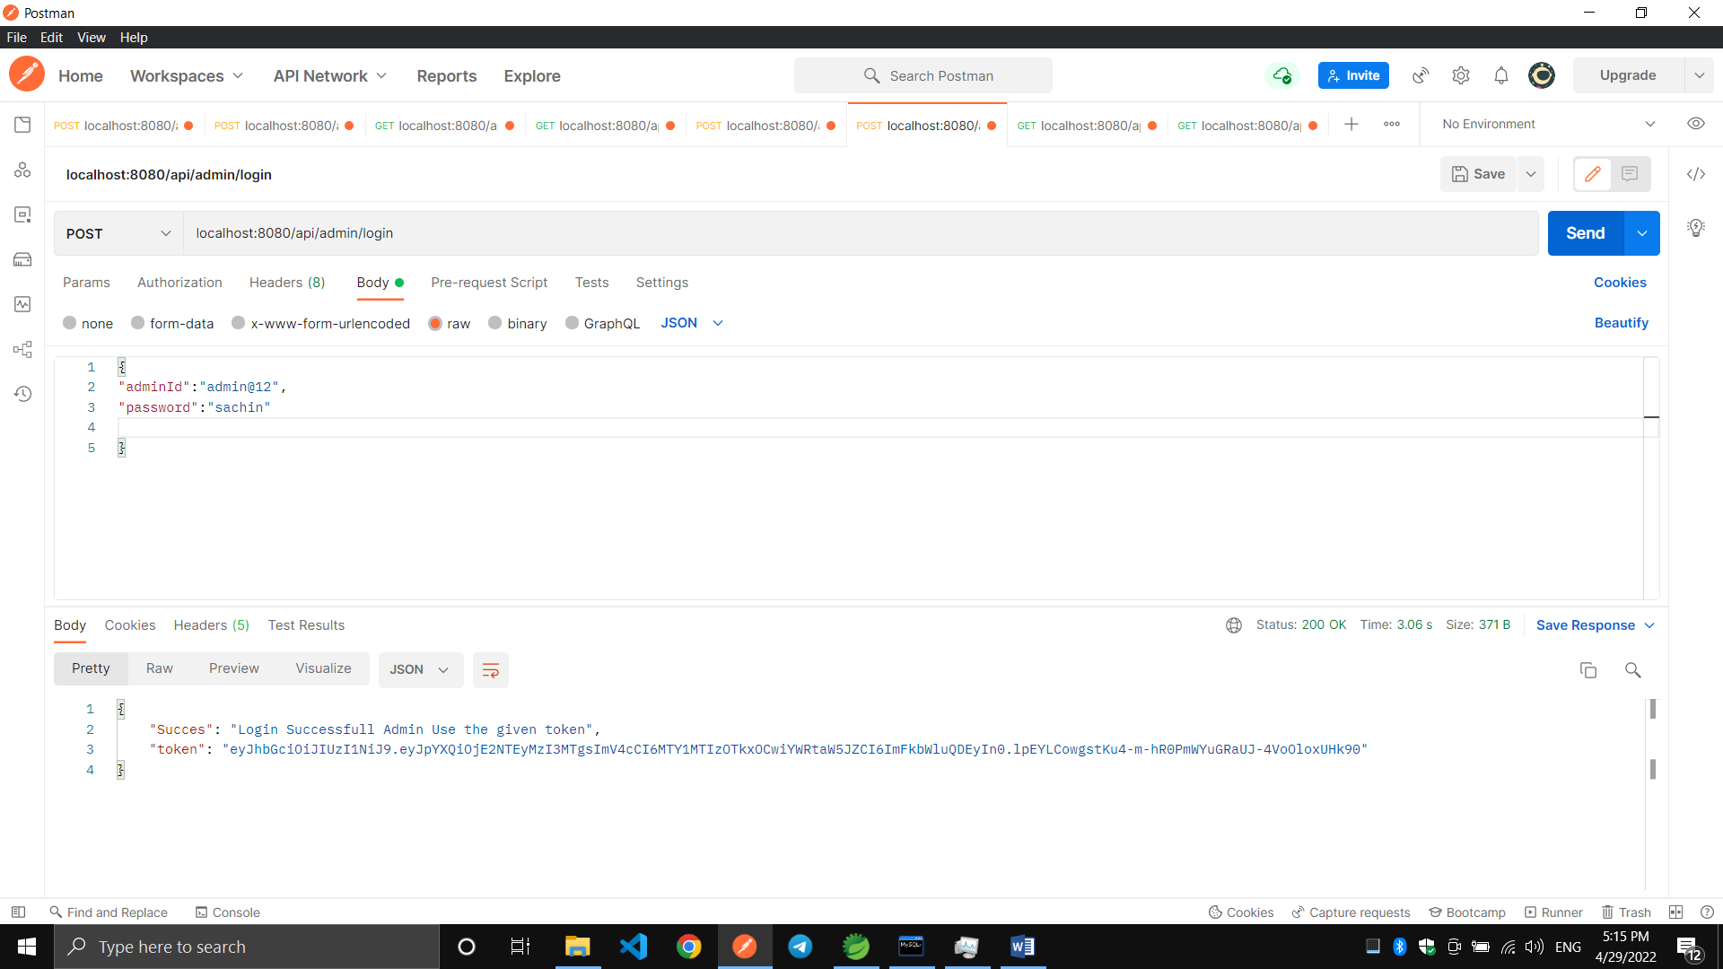

- Admin Password Change:-
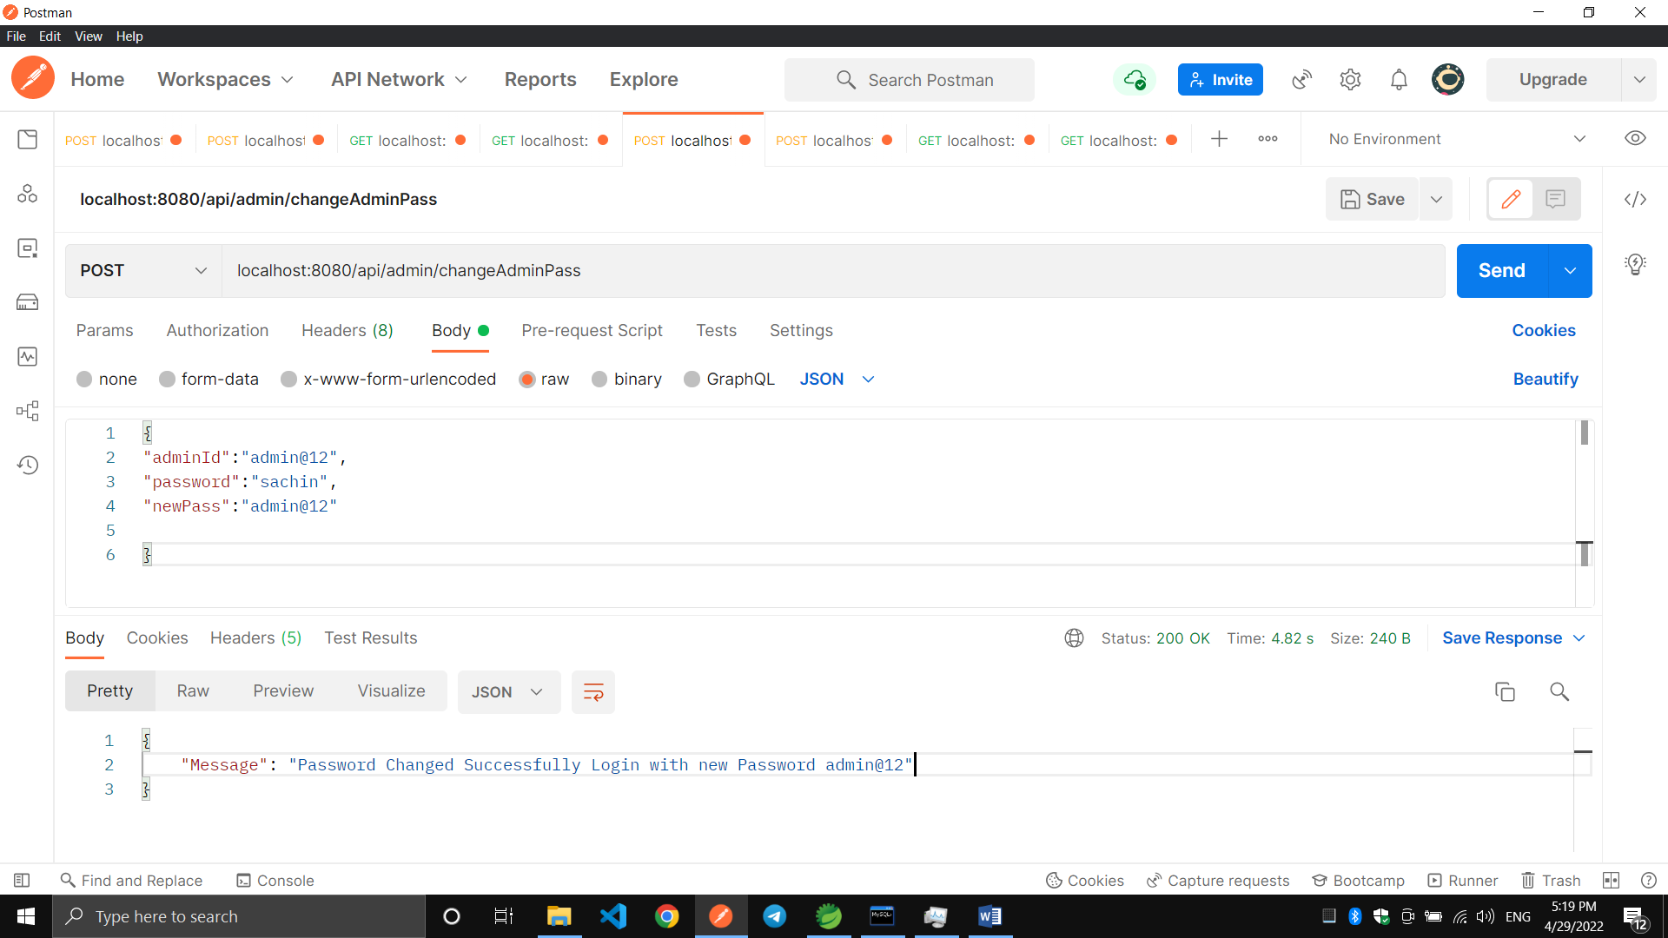

3.All Categories List:
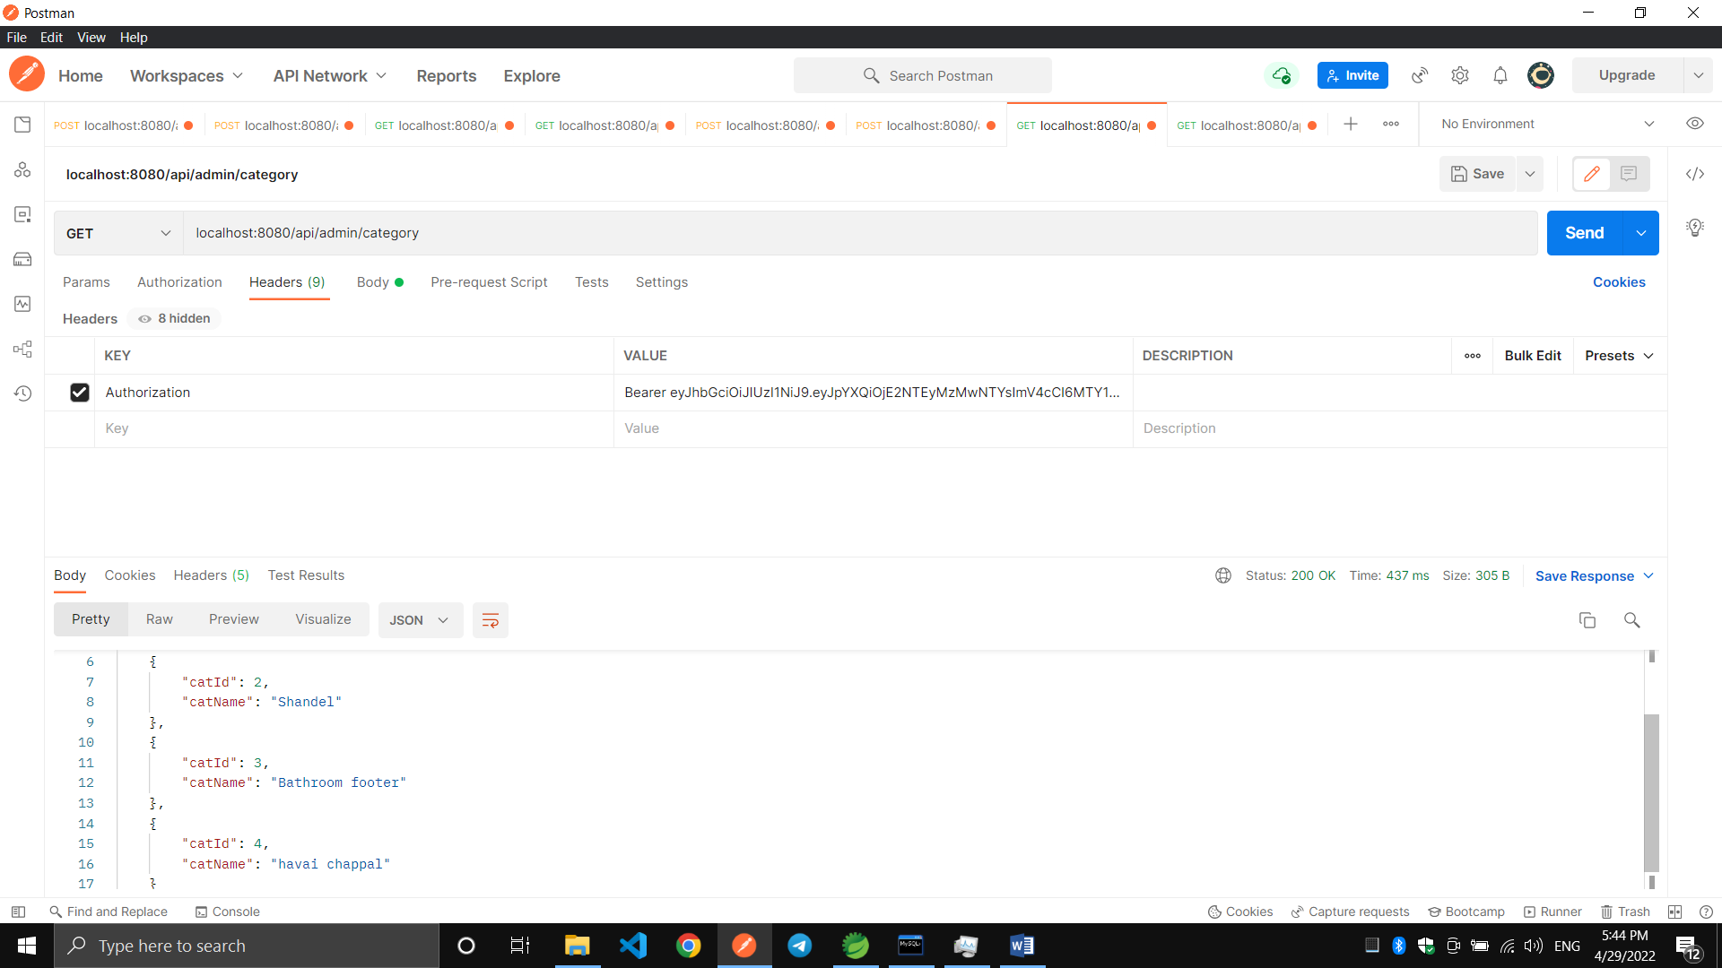

4.Category Fetching By Id:-
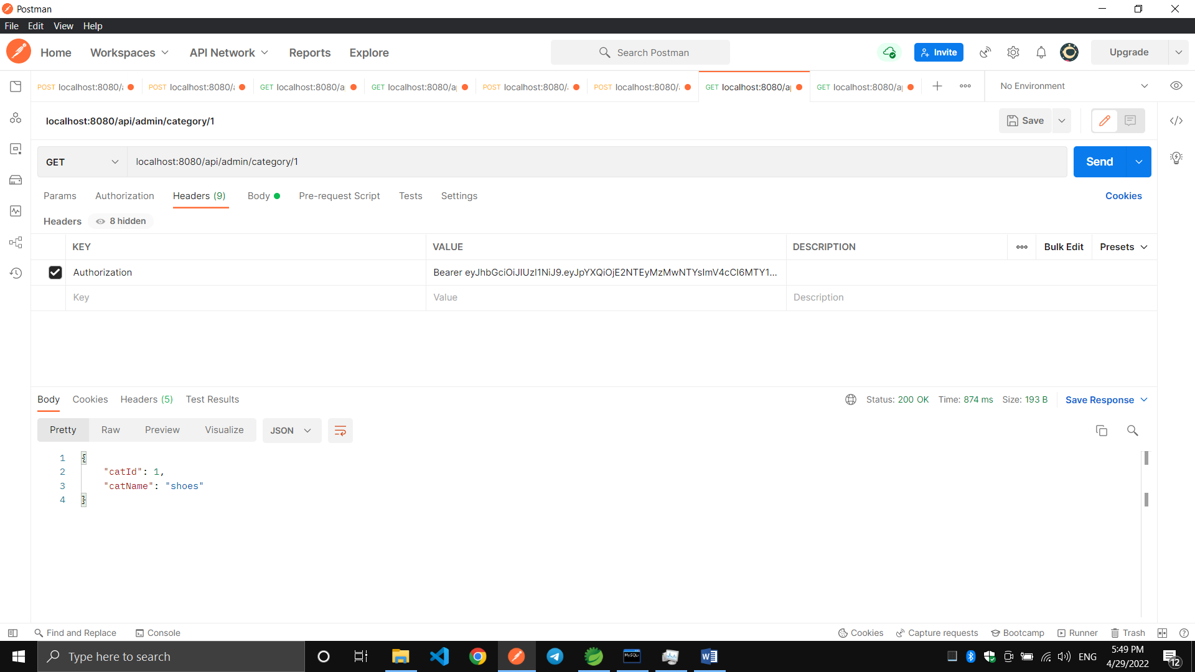

5.Adding new Category:-
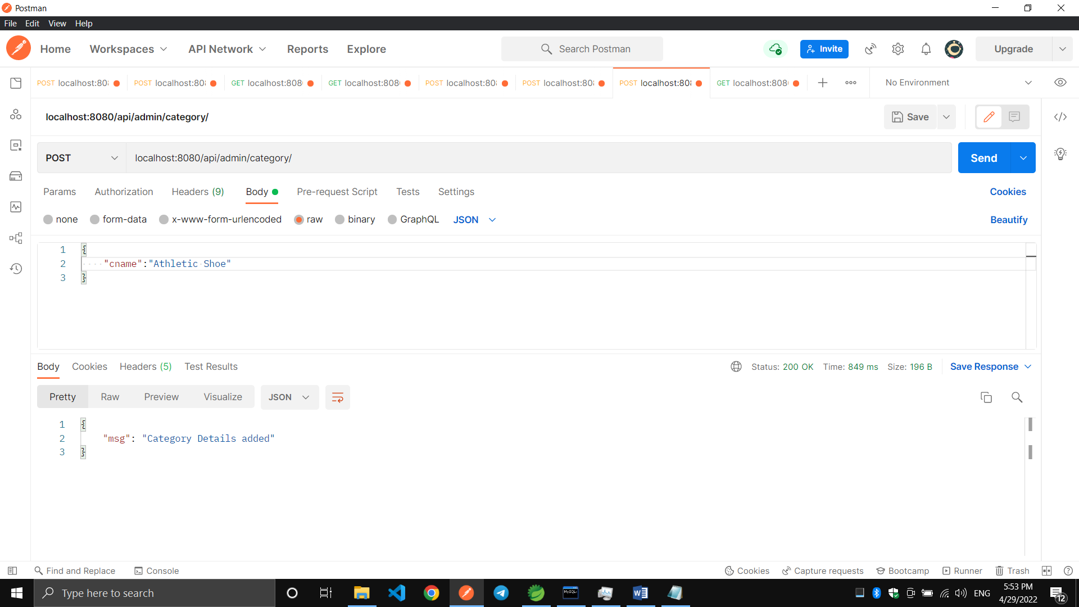

6.Deleting the Category By Id:
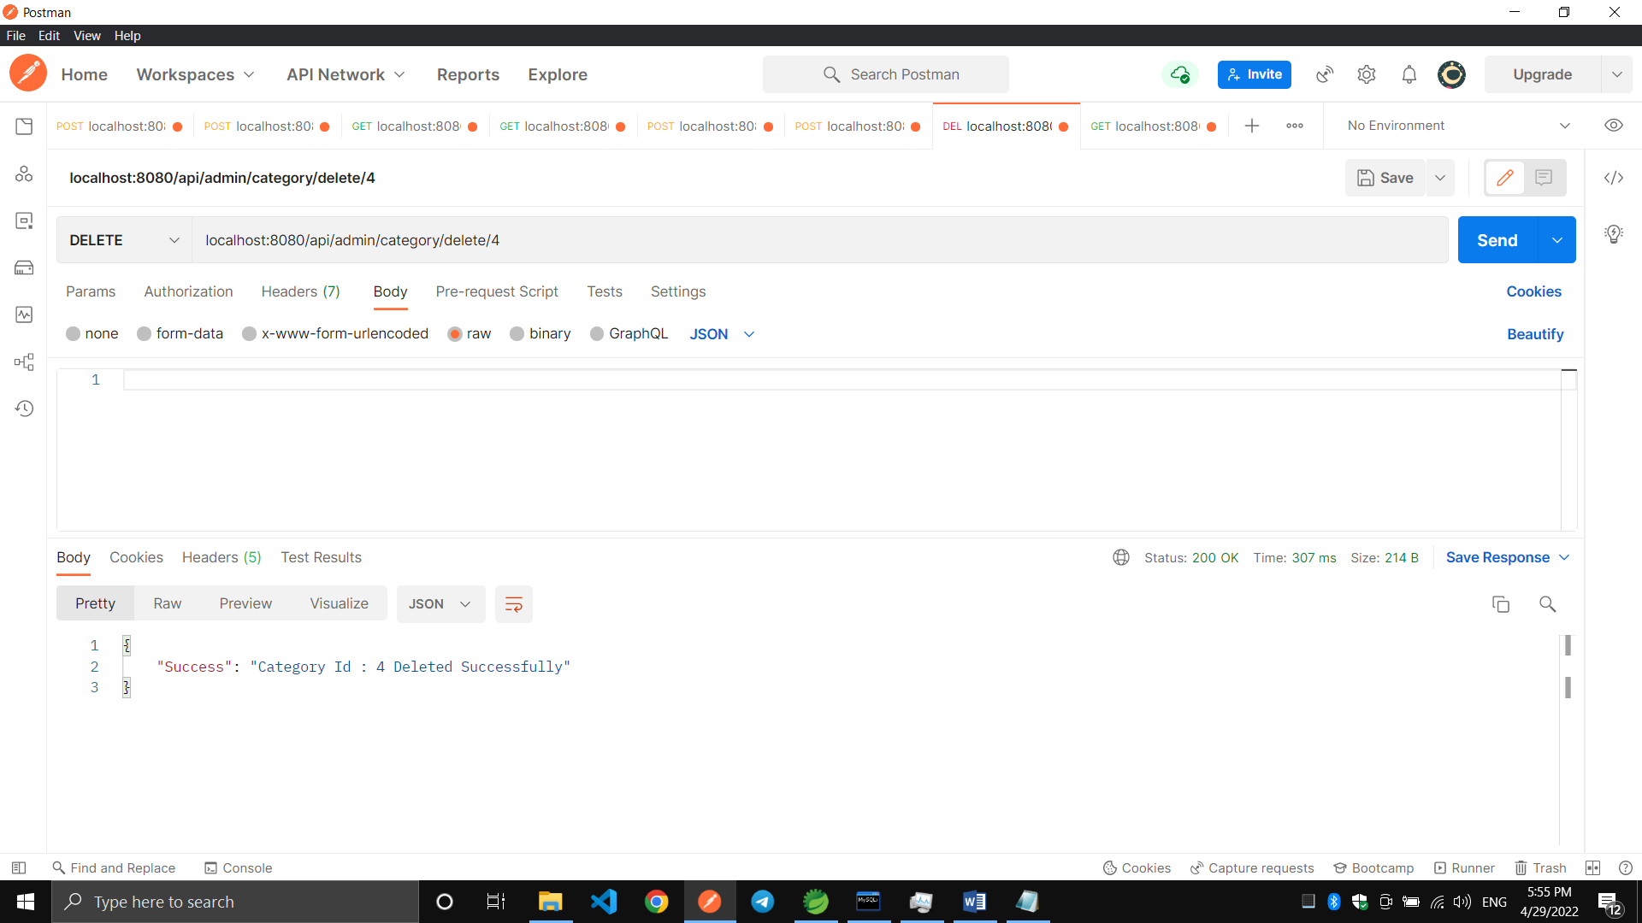

7.Getting the All Shoes Details:-
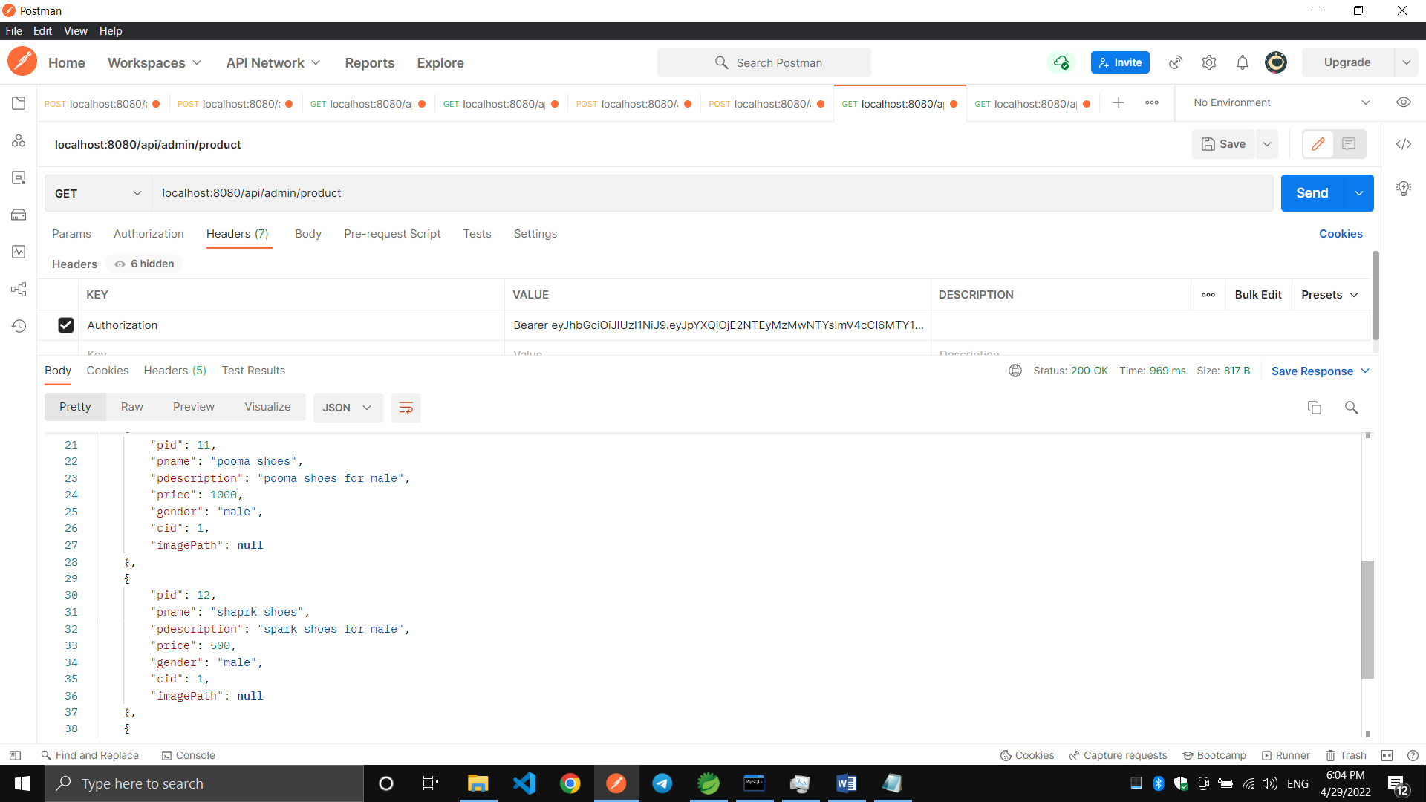

8.Adding new product:-
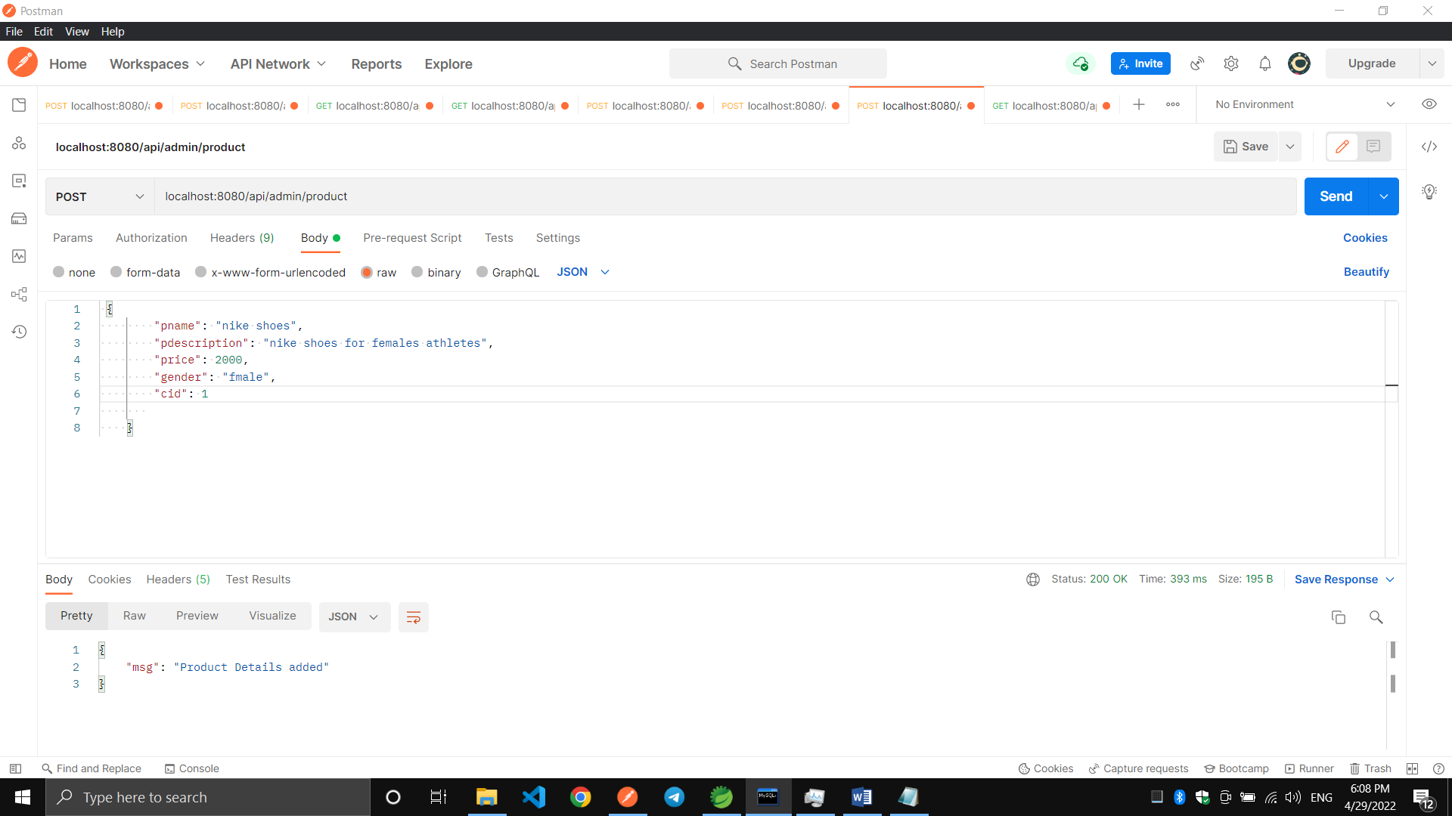

9.Getting the product details by Id:-
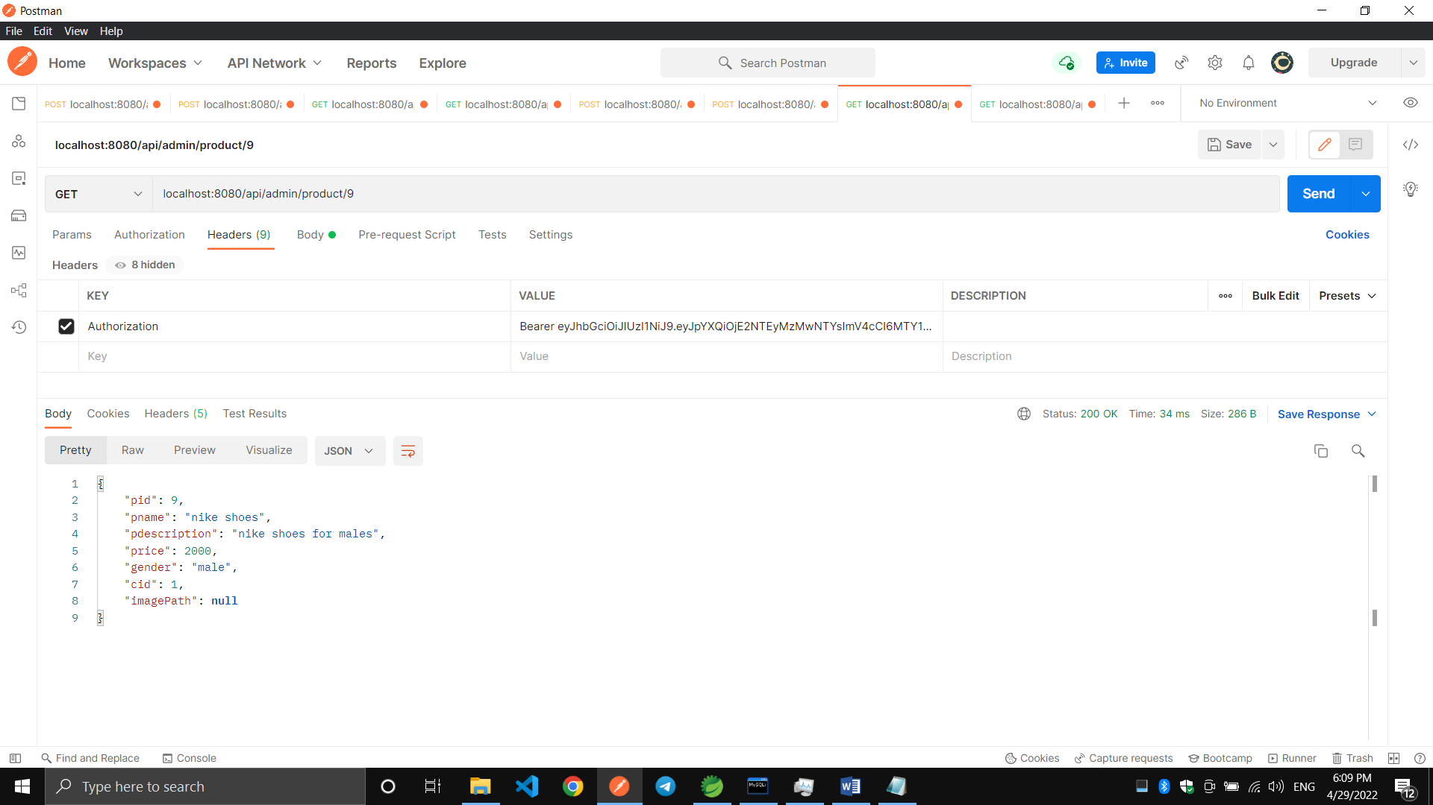

10.Deleting the product by Id:

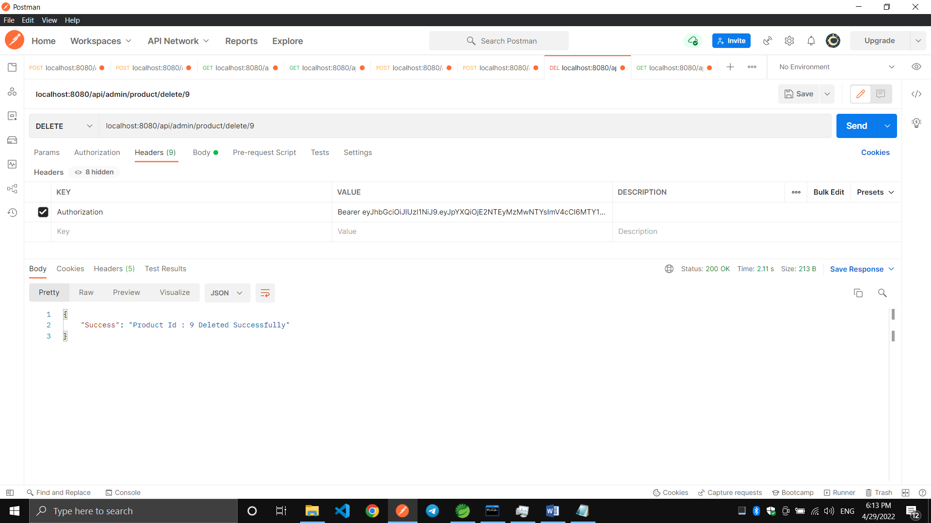

11.All Logged In User Details:-
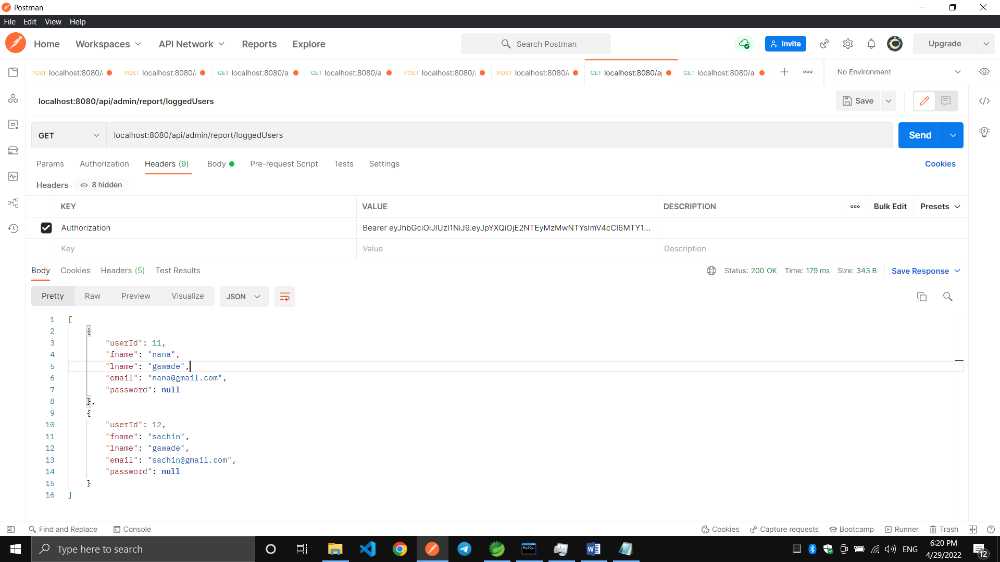

12.New User Registration :-
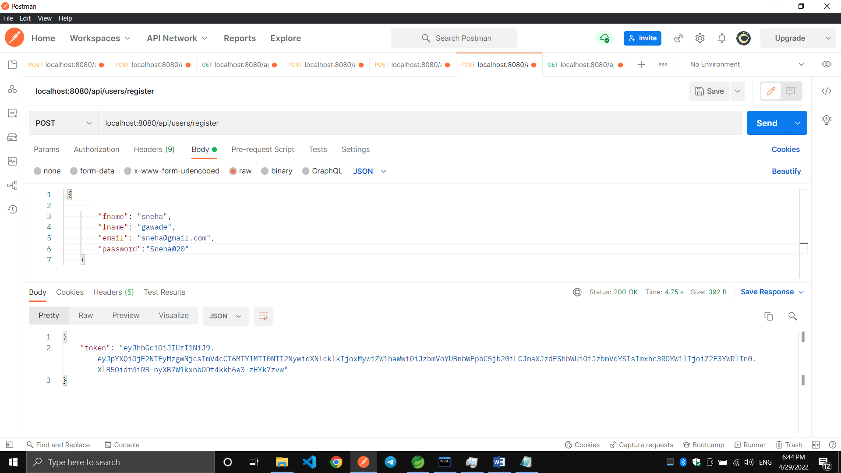

13.Login With Existing User:-
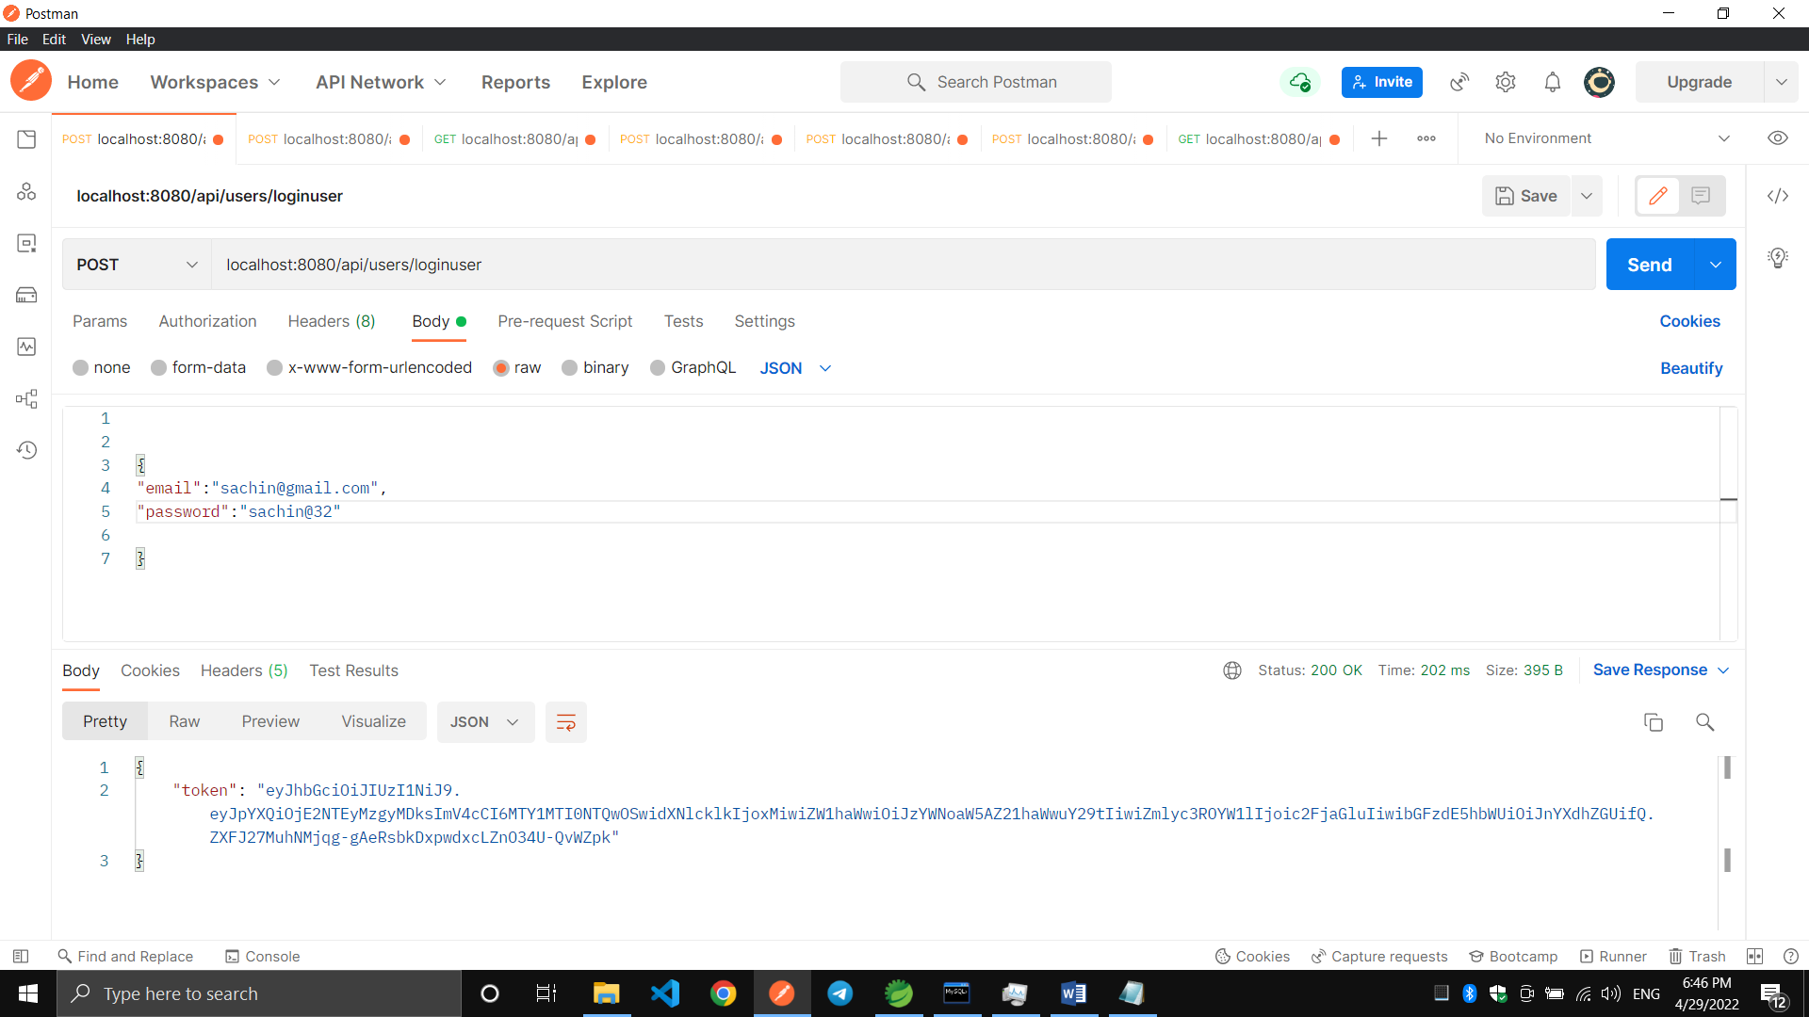

14:Product Details by Category Id:
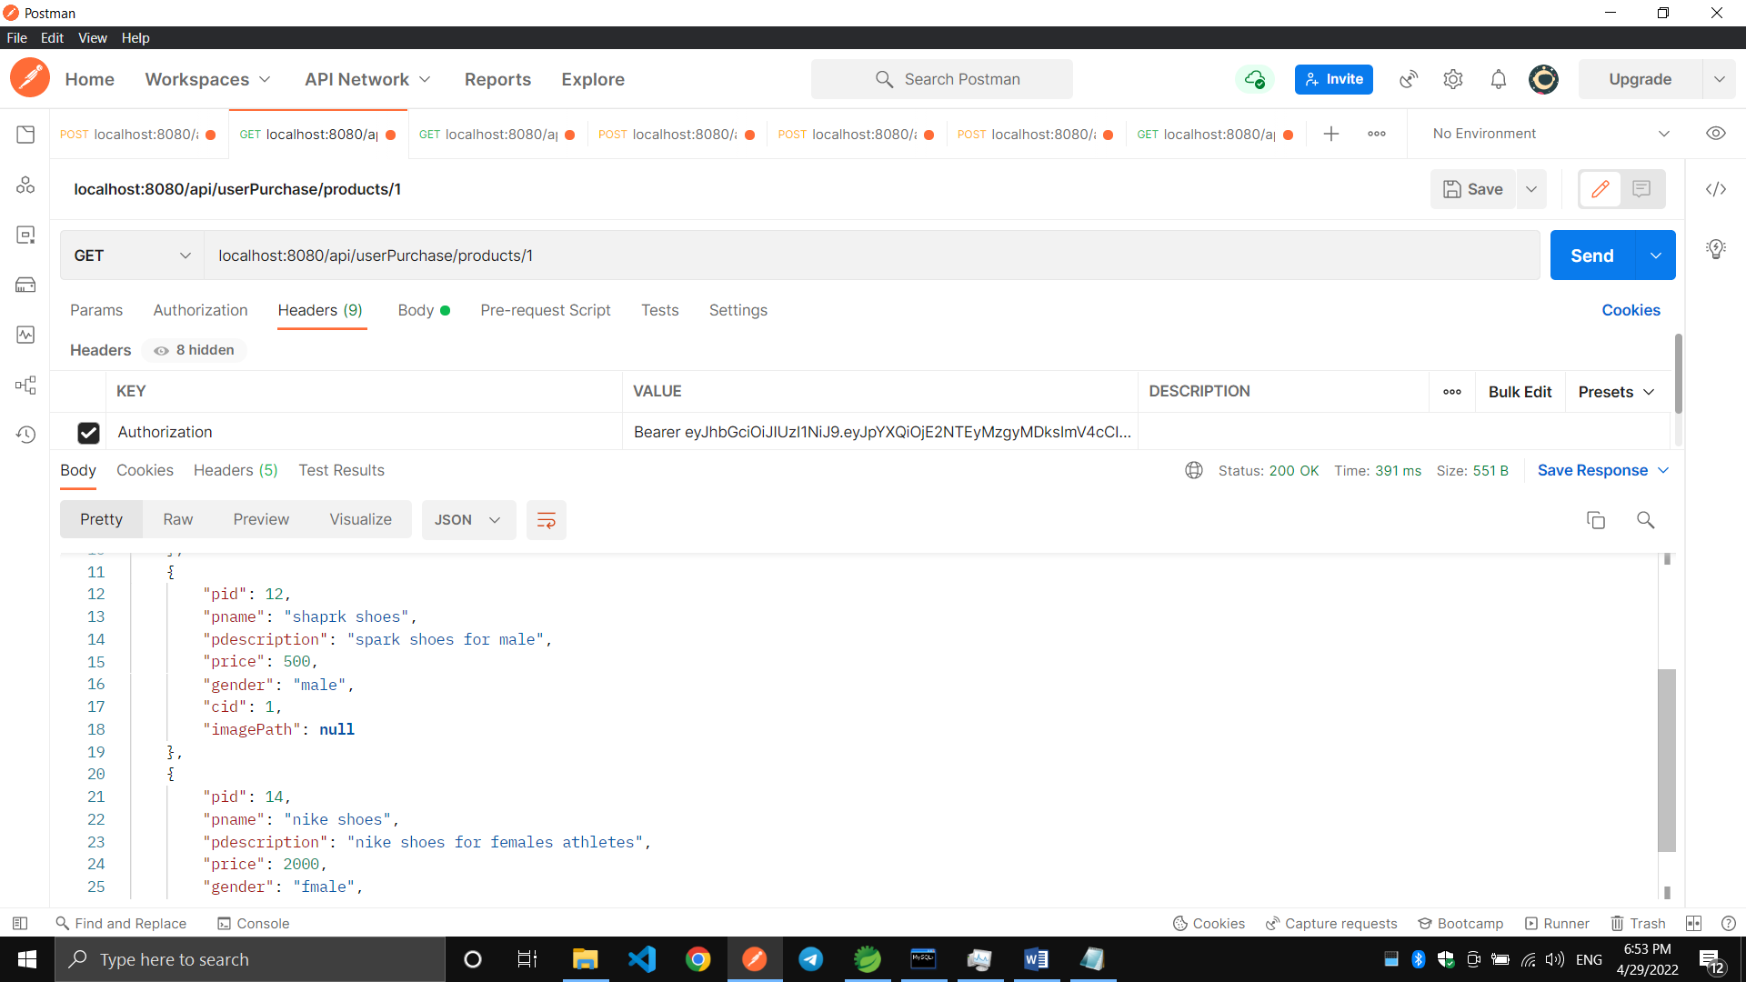

15. Purchased Product Details of Logged User:-
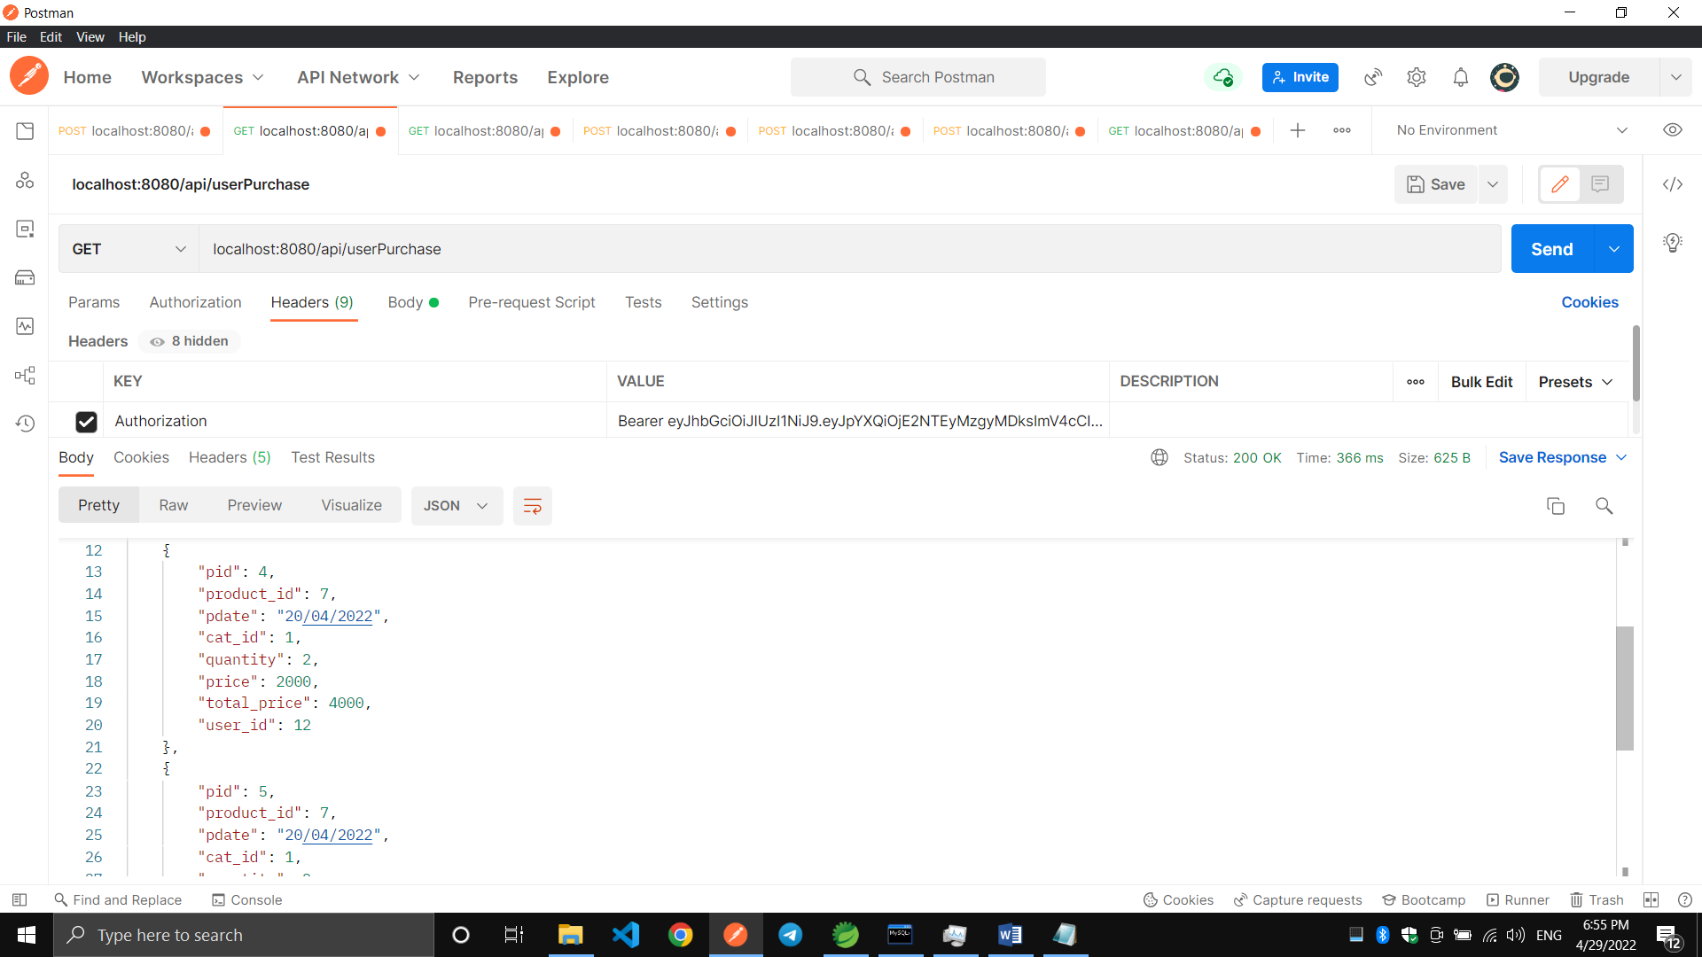

THANK YOU

